**VISVESVARAYA TECHNOLOGICAL UNIVERSITY**

**“JnanaSangama”, Belgaum- 590014, Karnataka.**



**LAB RECORD**

**on**

**Big Data Analytics (23CS6PCBDA)**

***Submitted by***

**Likhith M (1BM22CS135)**

***in partial fulfillment for the award of the degree of***

**BACHELOR OF ENGINEERING**

***in***

**COMPUTER SCIENCE AND ENGINEERING**



**B.M.S. COLLEGE OF ENGINEERING**

**(Autonomous Institution under VTU)**

**BENGALURU - 560019**

**February 2025 – July 2025**

**B.M.S. College of Engineering  
Bull Temple Road, Bangalore 560019**(Affiliated to Visvesvaraya Technological University, Belgaum)

**Department of Computer Science and Engineering**



**CERTIFICATE**

This is to certify that the Lab work entitled “Big Data Analytics” carried out by   
**Likhith M (1BM22CS135),** who is bonafide student of **B.M.S. College of Engineering.** It is in partial fulfilment for the award of **Bachelor of Engineering in Computer Science and Engineering** of the Visvesvaraya Technological University, Belgaum during the year 2025. The Lab report has been approved as it satisfies the academic requirements in respect of a Big Data Analytics (23CS6PCBDA) work prescribed for the said degree.

|  |  |
| --- | --- |
| **Leelavathi. B**  Assistant Professor  Department of CSE, BMSCE | **Dr. Kavitha Sooda**  Professor & HOD  Department of CSE, BMSCE |

**INDEX**

|  |  |  |  |
| --- | --- | --- | --- |
| **Sl.**  **No.** | **Date** | **Experiment Title** | **Page No.** |
| 1 | 04.03.25 | MongoDB- CRUD Operations Demonstration (Practice and Self Study) | 1 |
| 2 | 01.04.25 | Perform the following DB operations using Cassandra.   * Create a keyspace by name Employee * Create a column family by name   + Employee-Info with attributes   + Emp_Id Primary Key, Emp_Name, Designation,   + Date_of_Joining, Salary, Dept_Name * Insert the values into the table in batch * Update Employee name and Department of EmpId 121 * Sort the details of Employee records based on salary * Alter the schema of the table Employee_Info to add a column Projects which stores a set of Projects done by the corresponding Employee. * Update the altered table to add project names. * Create a TTL of 15 seconds to display the values of Employees. | 9 |
| 3 | 08.04.25 | Perform the following DB operations using Cassandra.   * Create a keyspace by name Library * Create a column family by name Library-Info with attributes   + Stud_Id Primary Key,   + Counter_value of type Counter,   + Stud_Name, Book-Name, Book-Id,   + Date_of_issue * Insert the values into the table in batch * Display the details of the table created and increase the value of the counter * Write a query to show that a student with id 112 has taken a book “BDA” 2 times. * Export the created column to a csv file * g) Import a given csv dataset from local file system into Cassandra column family | 12 |
| 4 | 15.04.25 | Execution of HDFS Commands for interaction with Hadoop Environment. (Minimum 10 commands to be executed) | 17 |
| 5 | 15.04.25 | Implement Wordcount program on Hadoop framework | 20 |
| 6 | 06.05.25 | From the following link extract the weather data  <https://github.com/tomwhite/hadoop-book/tree/master/input/ncdc/all>   * Create a MapReduce program to find average temperature for each year from NCDC data set. * b) find the mean max temperature for every month | 24 |
| 7 | 20.05.25 | For a given Text file, Create a Map Reduce program to sort the content in an alphabetic order listing only top 10 maximum occurrences of words. | 33 |
| 8 | 20.05.25 | Write a Scala program to print numbers from 1 to 100 using for loop. | 38 |
| 9 | 20.05.25 | Using RDD and FlatMap count how many times each word appears in a file and write out a list of words whose count is strictly greater than 4 using Spark. | 39 |
| 10 | 20.05.25 | Write a simple streaming program in Spark to receive text data streams on a particular port, perform basic text cleaning (like white space removal, stop words removal, lemmatization, etc.), and print the cleaned text on the screen. (Open Ended Question). | 40 |

Github Link: <https://github.com/01-BLUELOTUS/BDA-1BM22CS135.git>

**Course Outcomes (COs):**

|  |  |
| --- | --- |
| **CO1** | Apply the concept of NoSQL, Hadoop or Spark for a given task |
| **CO2** | Analyse big data analytics mechanisms that can be applied to obtain solution for a given problem. |
| **CO3** | Design and implement solutions using data analytics mechanisms for a given problem. |

**LABORATORY PROGRAM – 1**

**MongoDB- CRUD Operations Demonstration (Practice and Self Study)**

OBSERVATION

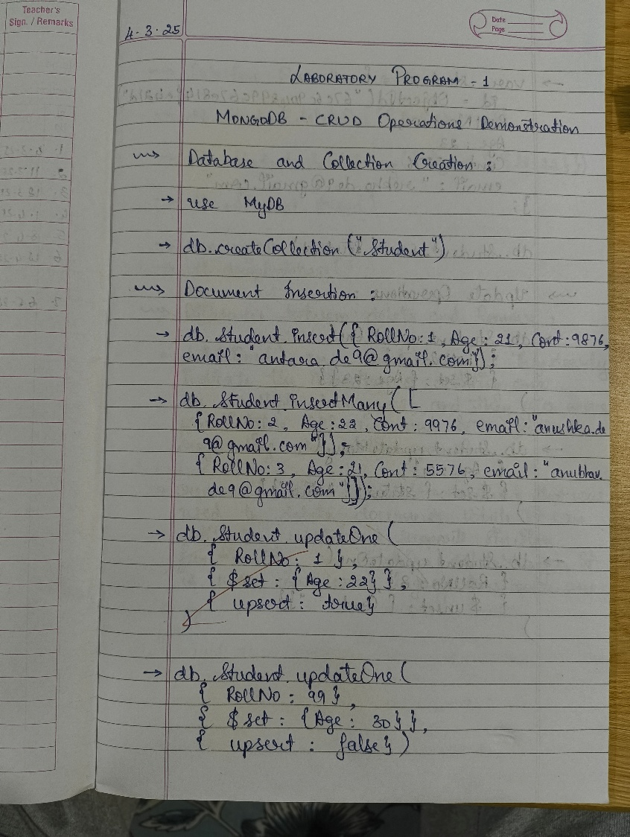

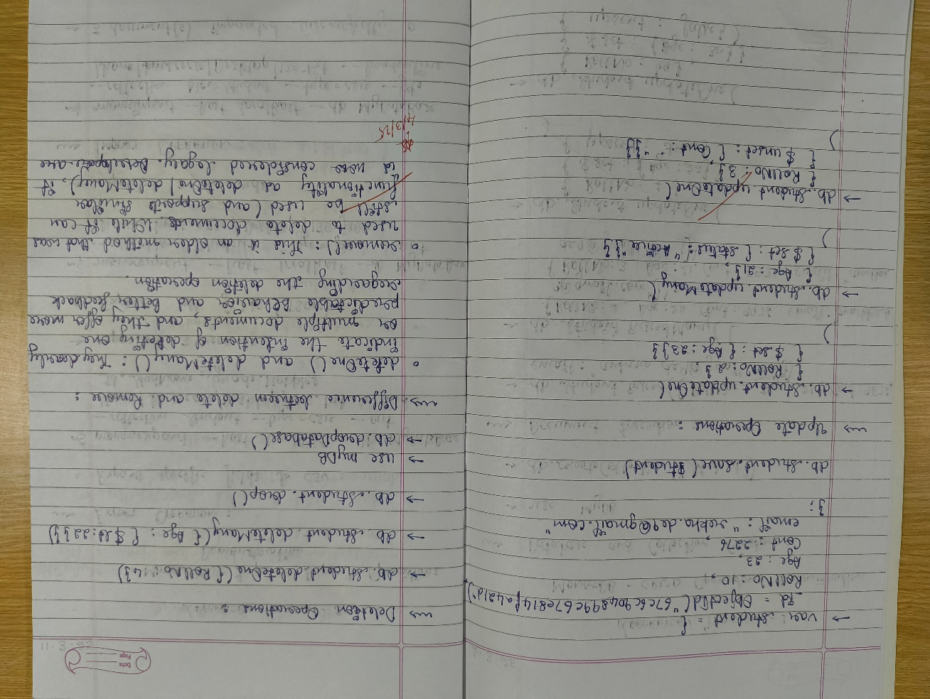

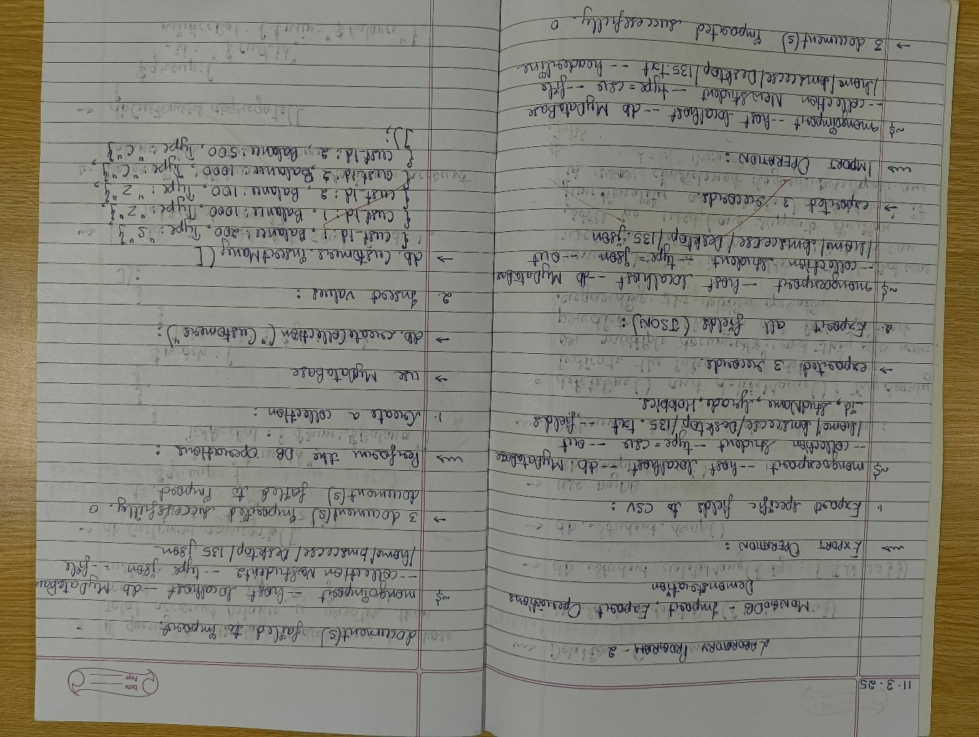

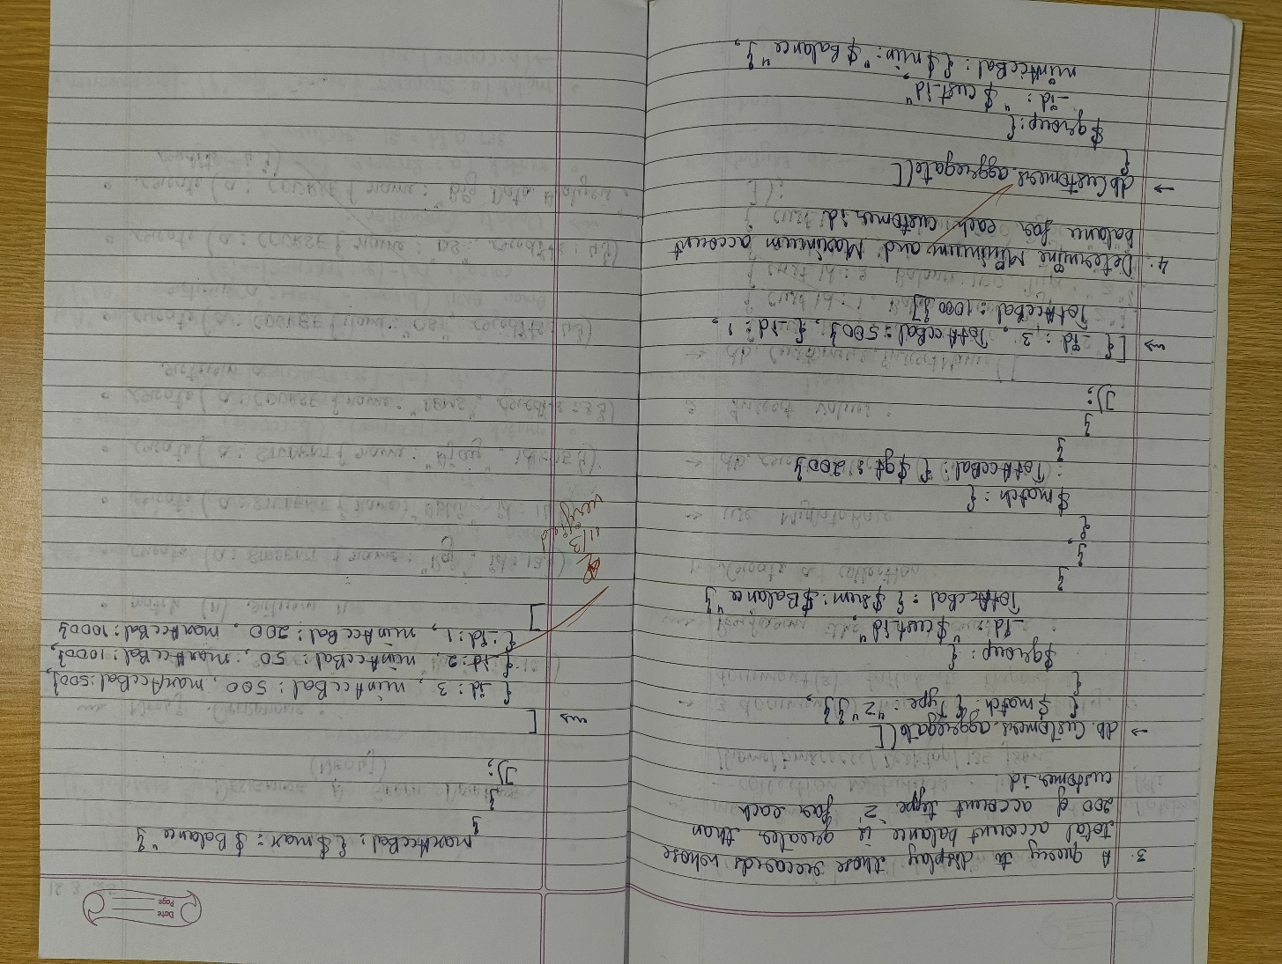

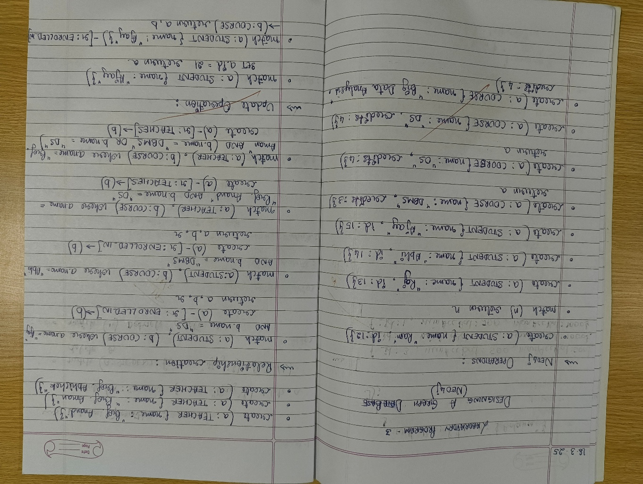

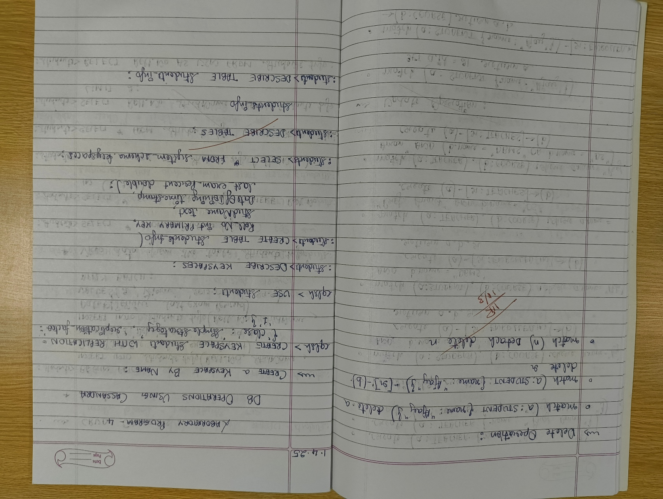

COMMAND WITH OUTPUT - USING ATLAS

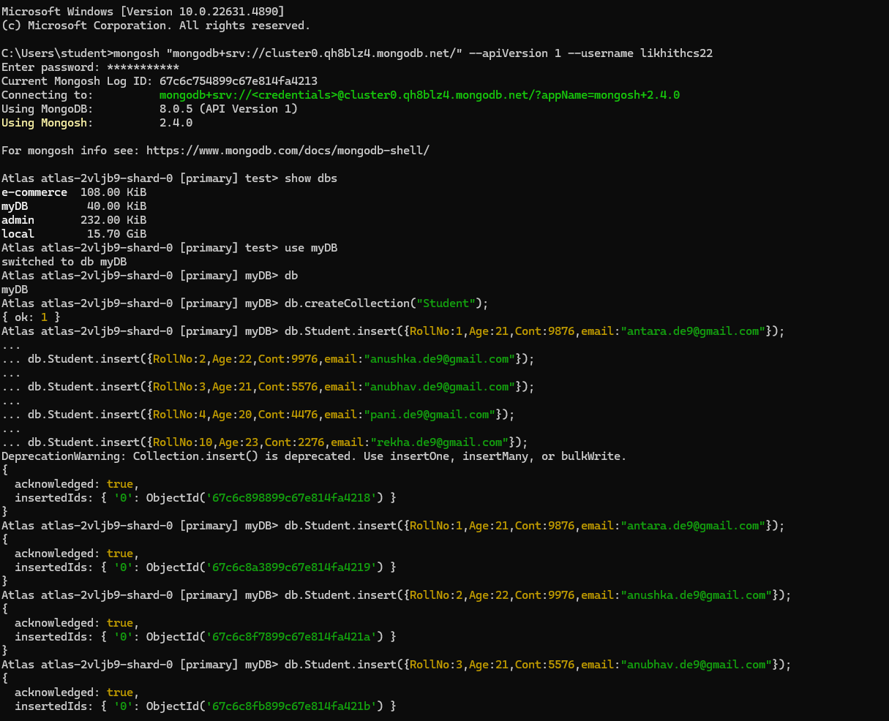

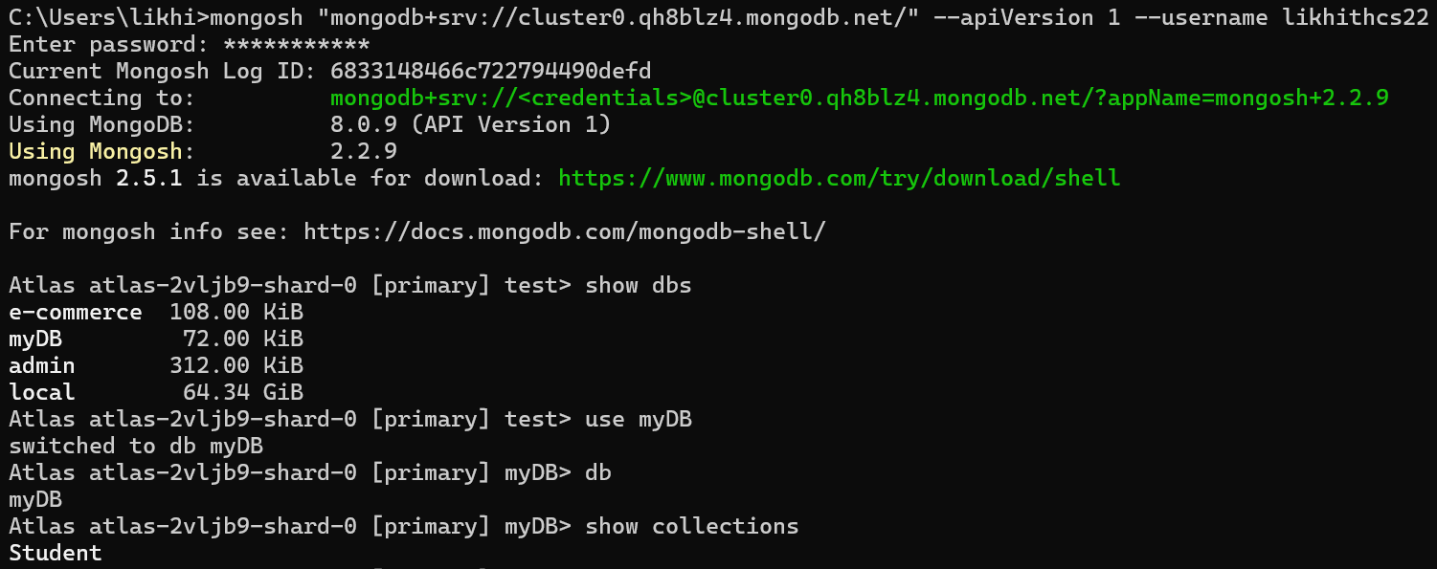

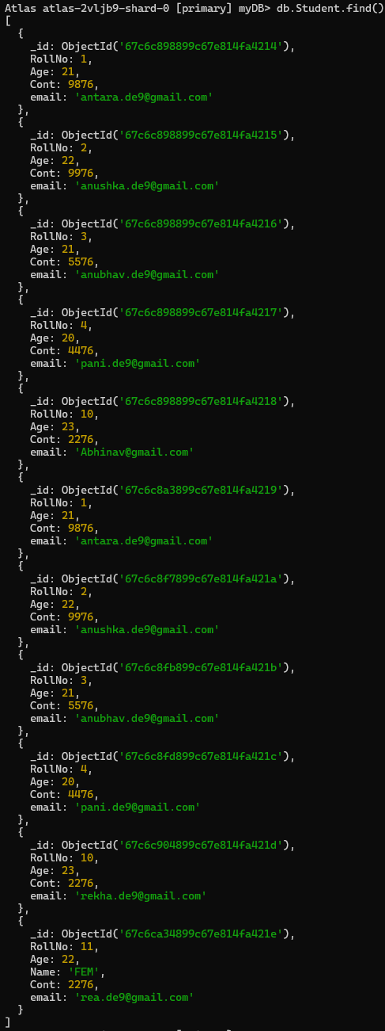

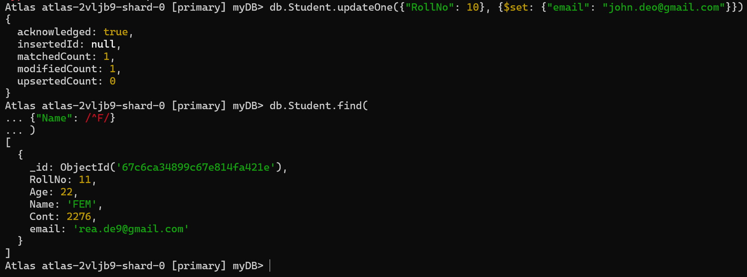

**MongoDB- CRUD Operations Demonstration (Practice and Self Study)**

COMMAND WITH OUTPUT - USING UBUNTU TERMINAL

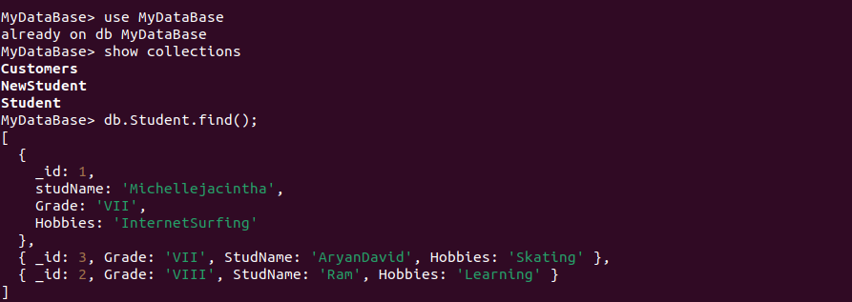

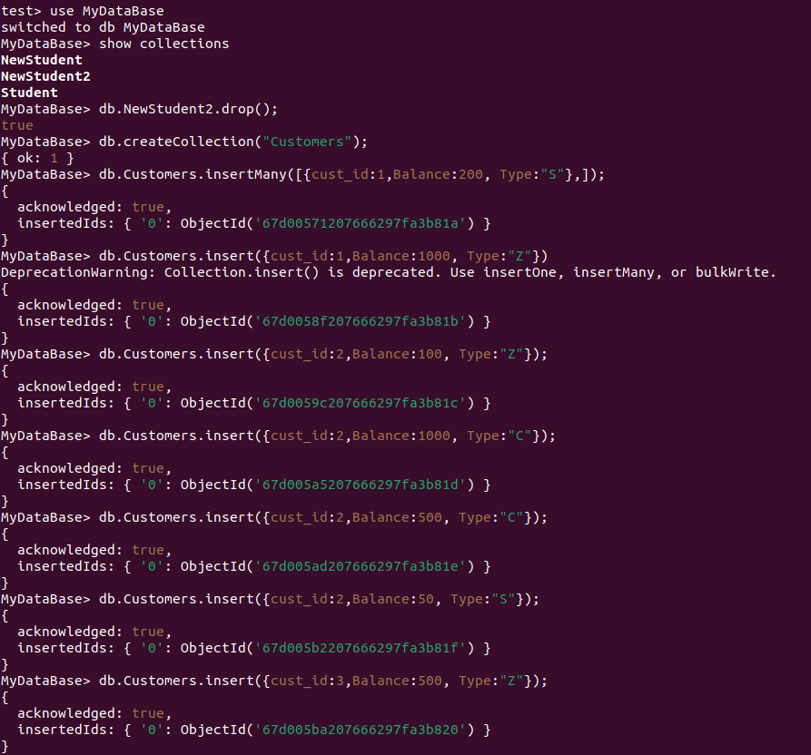

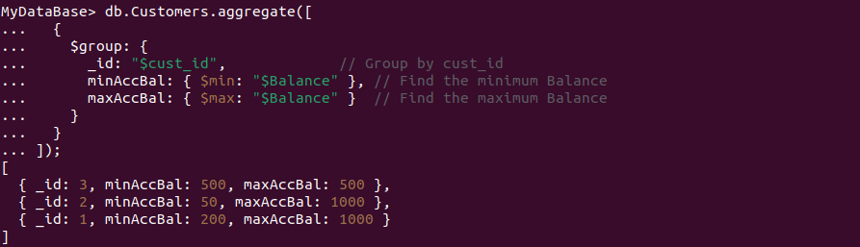

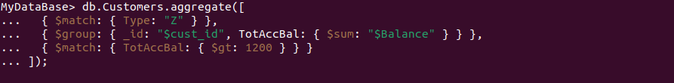

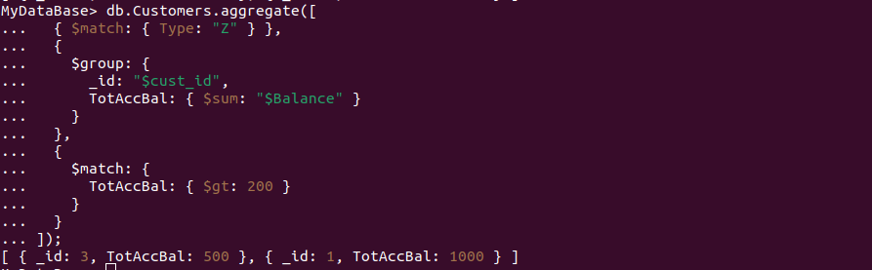

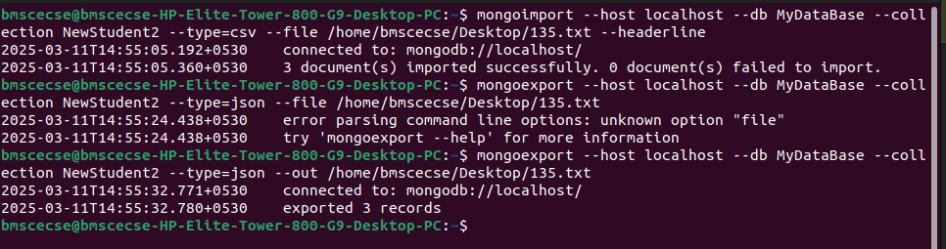

**LABORATORY PROGRAM – 2**

**Perform the following DB operations using Cassandra**

**Questions:**

1. a) Create a keyspace by name Employee
2. b) Create a column family by name

* Employee-Info with attributes
* Emp_Id Primary Key, Emp_Name,
* Designation, Date_of_Joining,
* Salary, Dept_Name

1. c) Insert the values into the table in batch
2. d) Update Employee name and Department of Emp-Id 121
3. e) Sort the details of Employee records based on salary
4. f) Alter the schema of the table Employee_Info to add a column Projects which stores a set of Projects done by the corresponding Employee.
5. g) Update the altered table to add project names.
6. h) Create a TTL of 15 seconds to display the values of Employees.
7. OBSERVATION

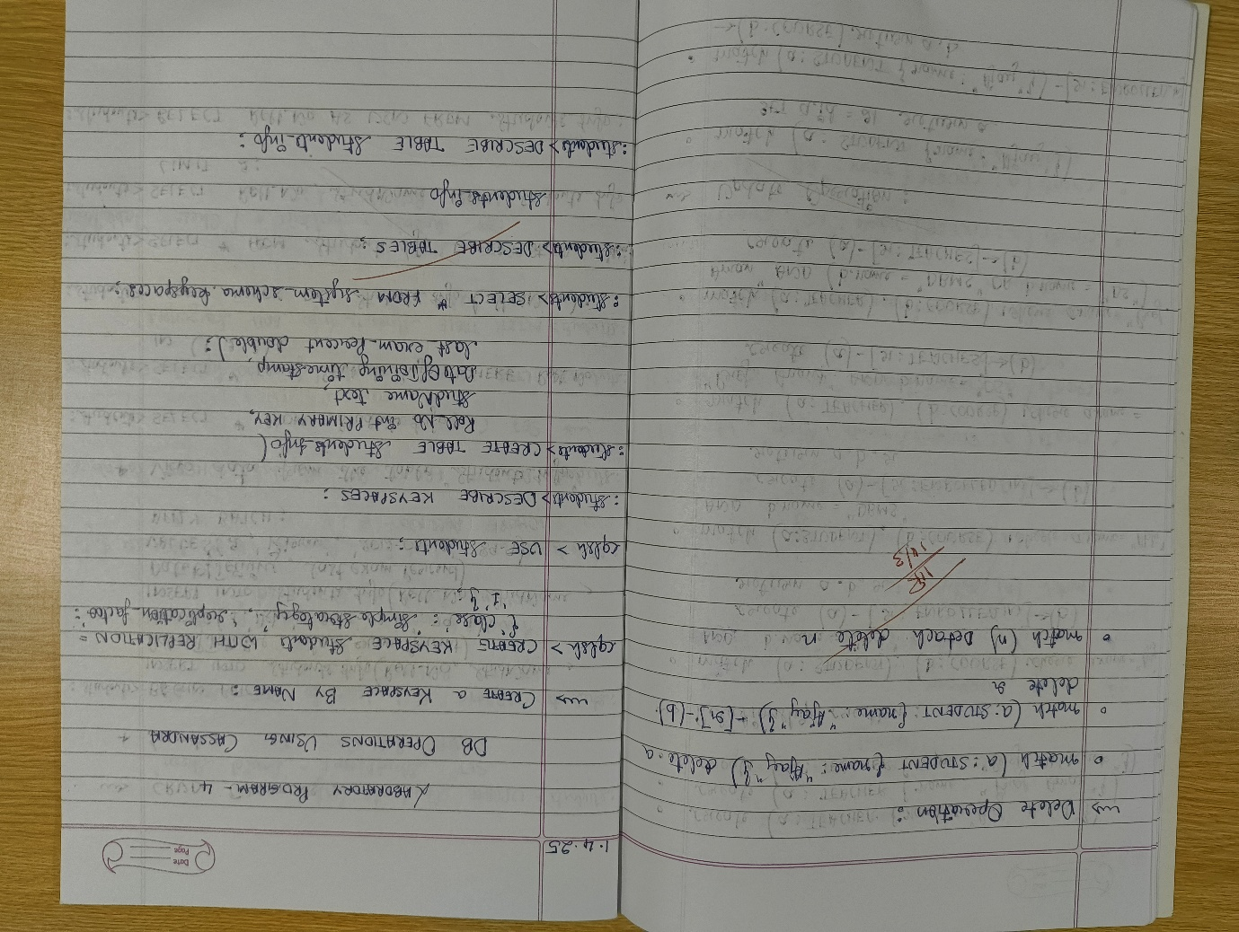

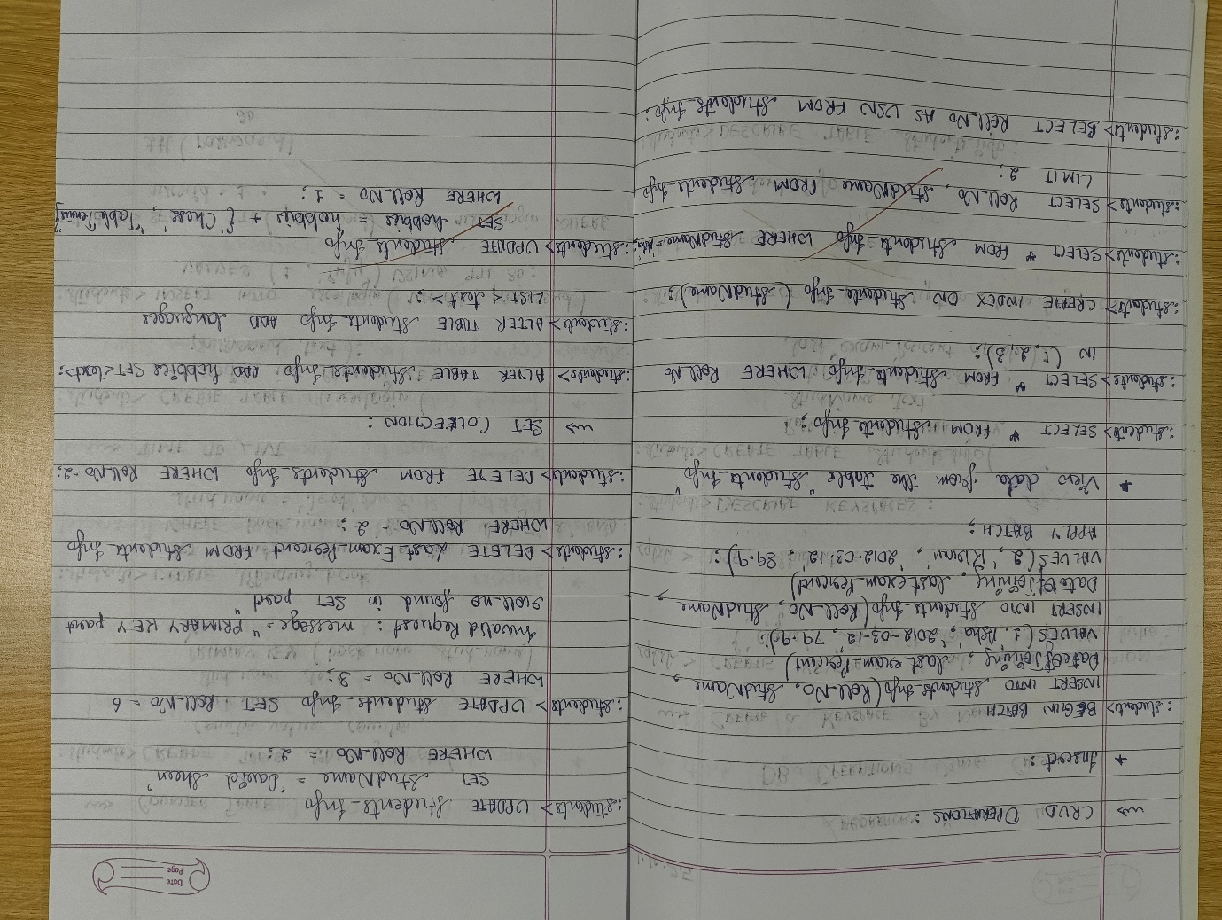

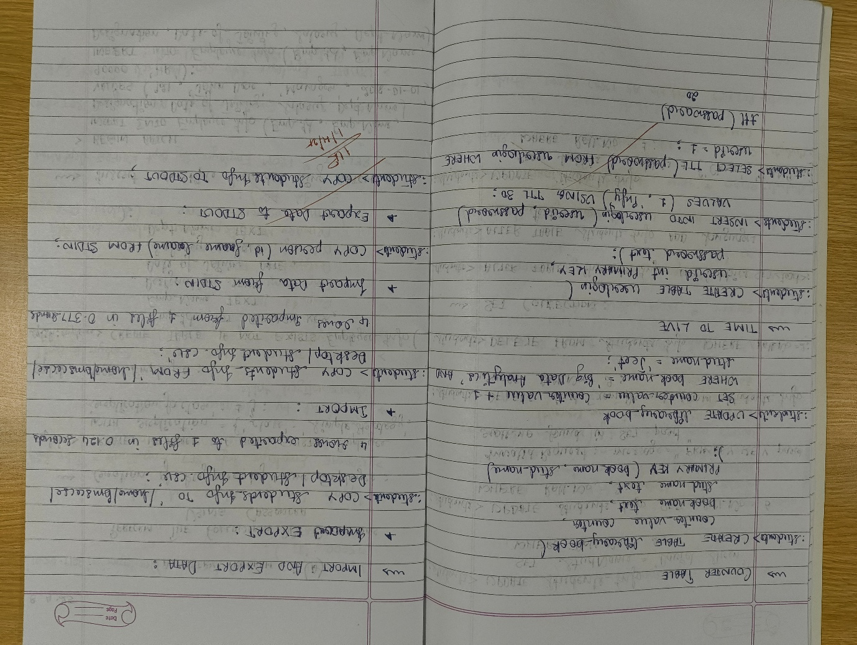

COMMAND WITH OUTPUT

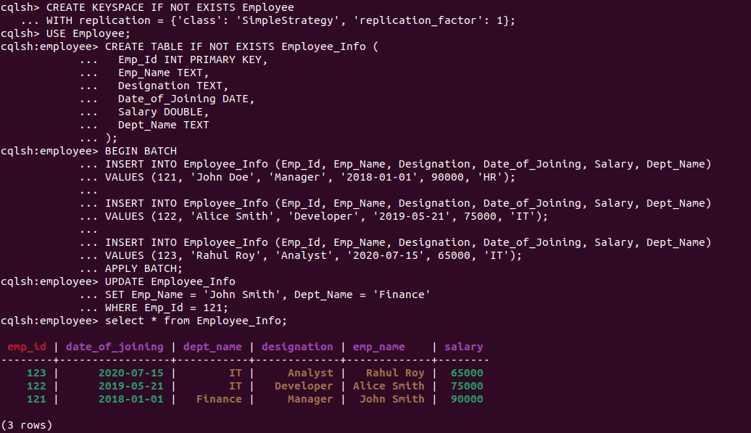

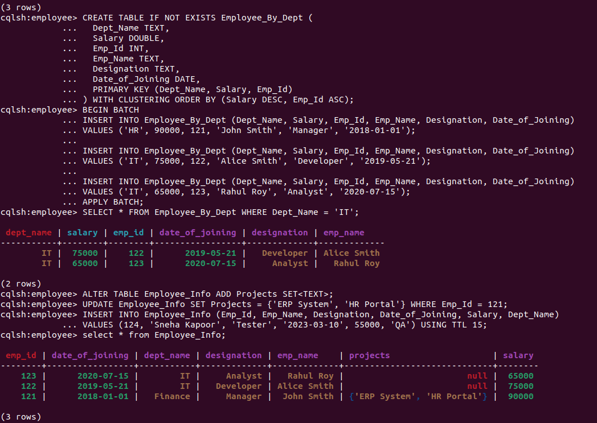

**LABORATORY PROGRAM – 3**

**Perform the following DB operations using Cassandra**

**Questions:**

1. a) Create a keyspace by name Library
2. b) Create a column family by name Library-Info with attributes
   * + - * Stud_Id Primary Key,
         * Counter_value of type Counter,
         * Stud_Name, Book-Name, Book-Id,
         * Date_of_issue
3. c) Insert the values into the table in batch
4. d) Display the details of the table created and increase the value of the counter
5. e) Write a query to show that a student with id 112 has taken a book “BDA” 2 times.
6. f) Export the created column to a csv file
7. g) Import a given csv dataset from local file system into Cassandra column family
8. OBSERVATION

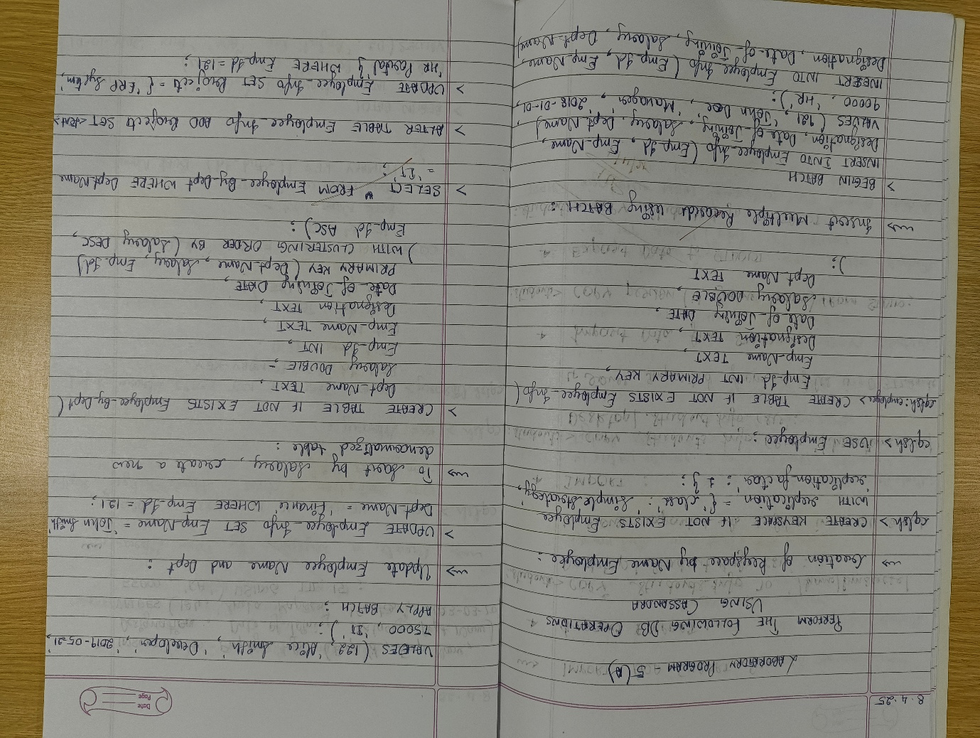

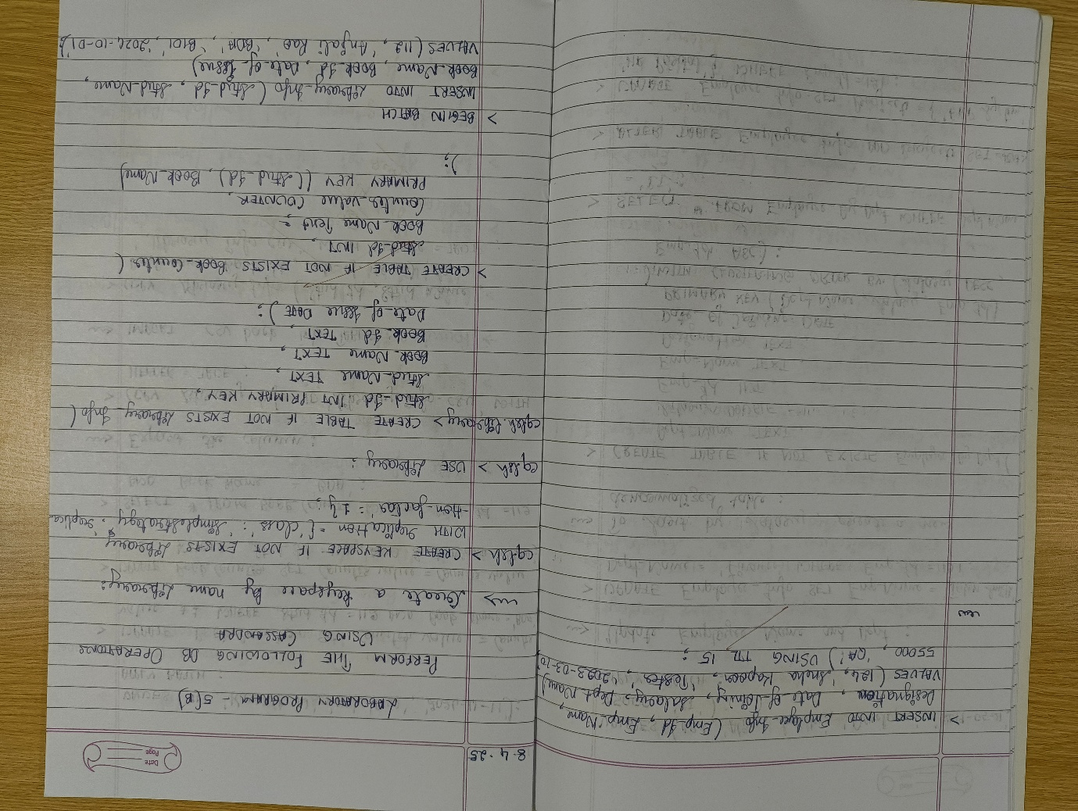

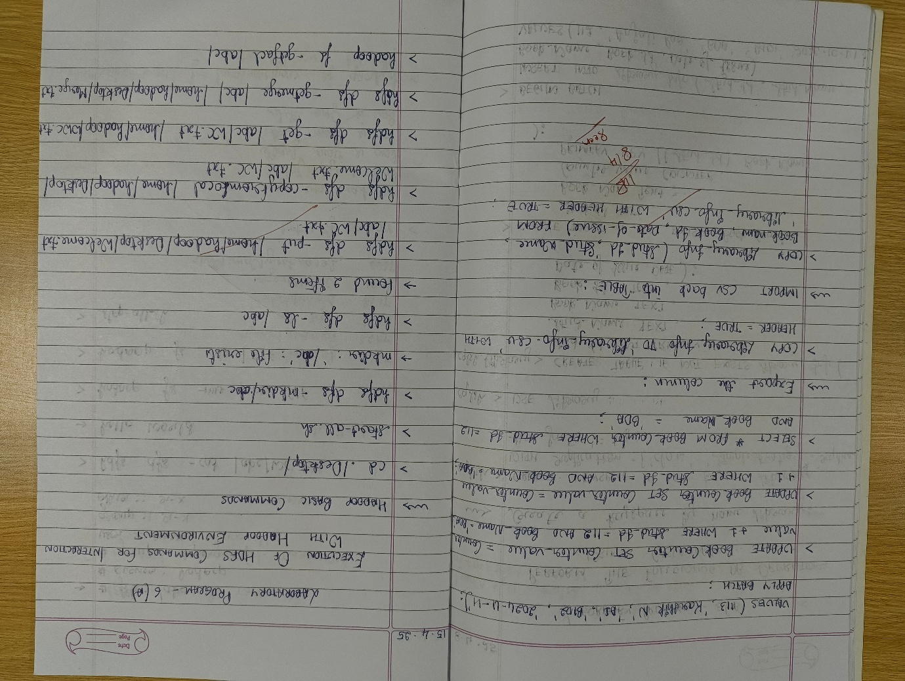

COMMAND WITH OUTPUT

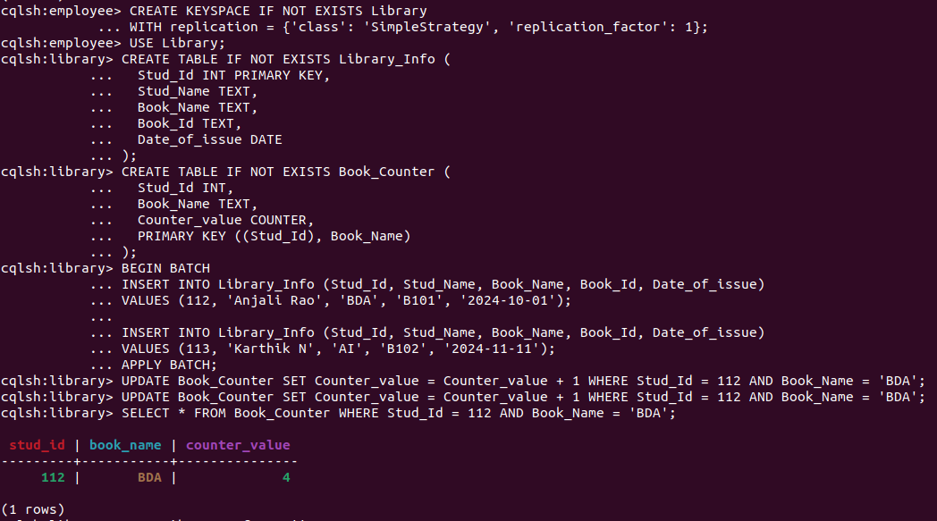

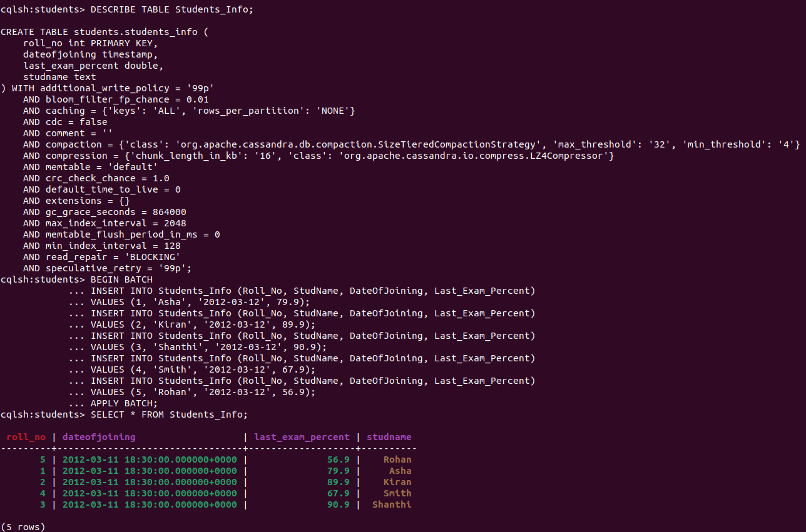

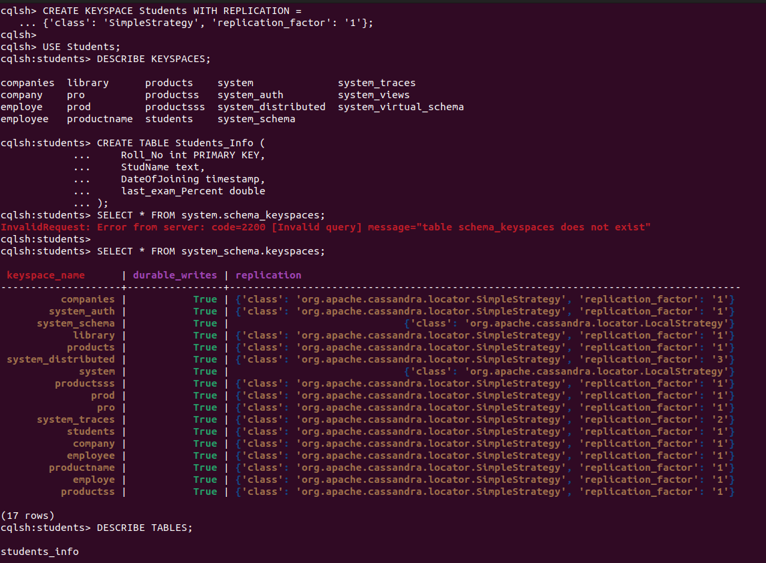

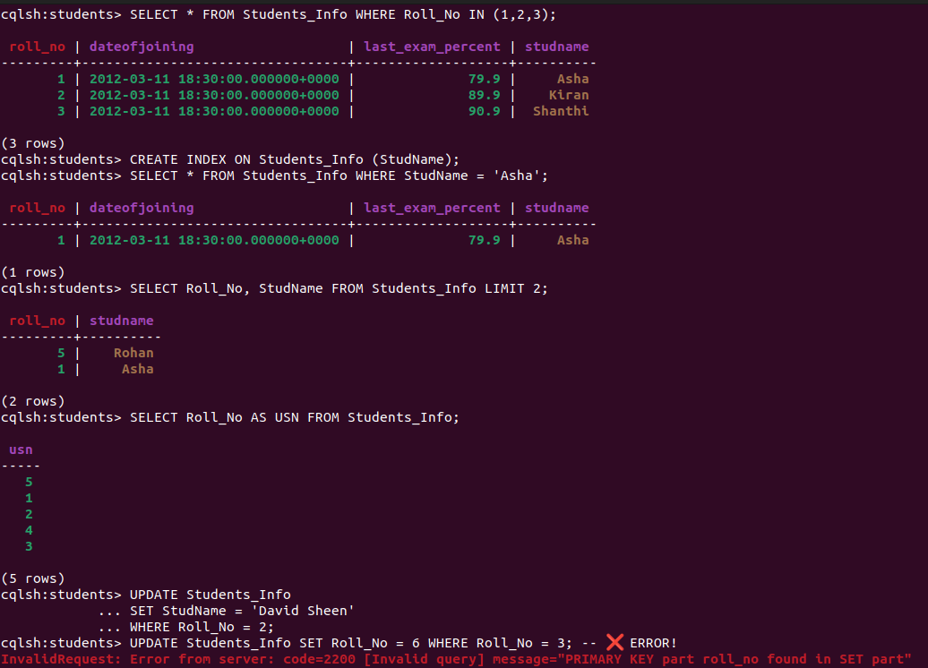

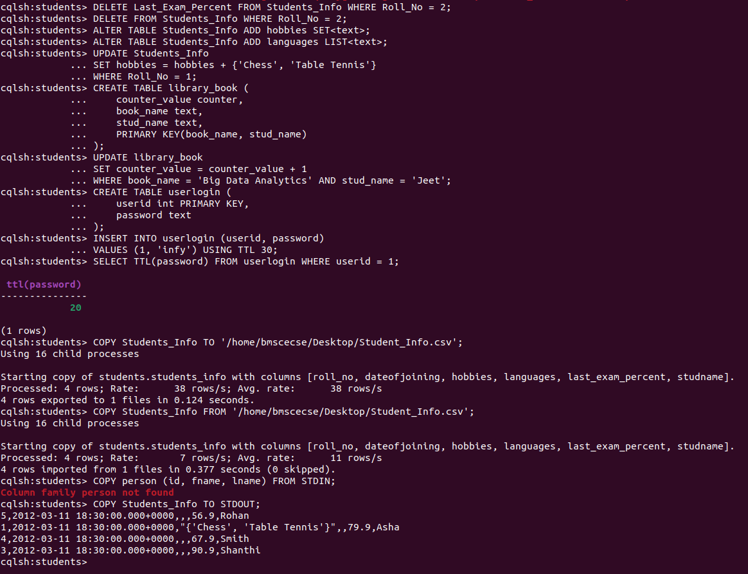

**LABORATORY PROGRAM – 4**

**Execution of HDFS Commands for interaction with Hadoop Environment. (Minimum 10 commands to be executed)**

1. OBSERVATION

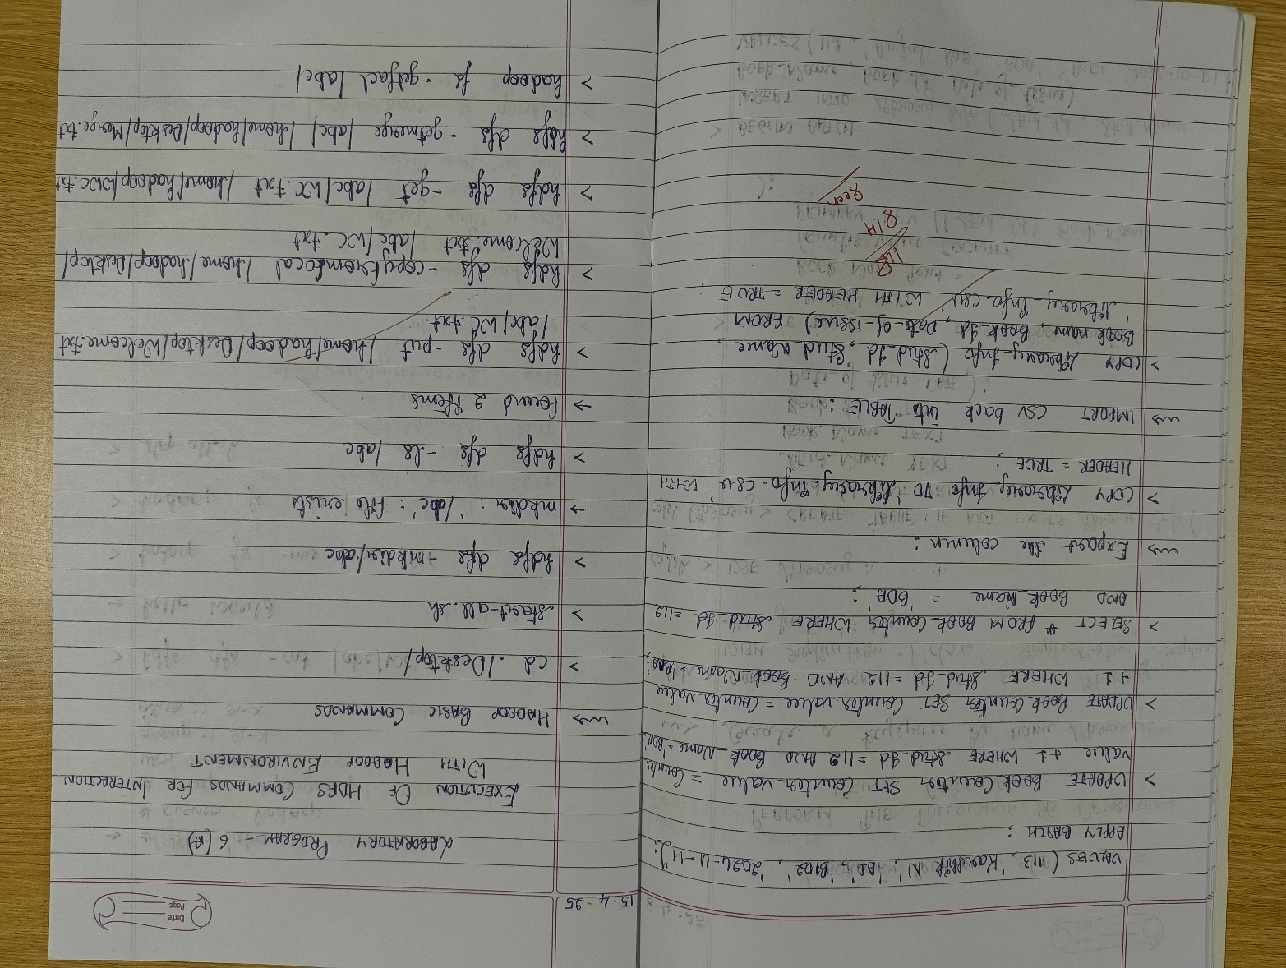

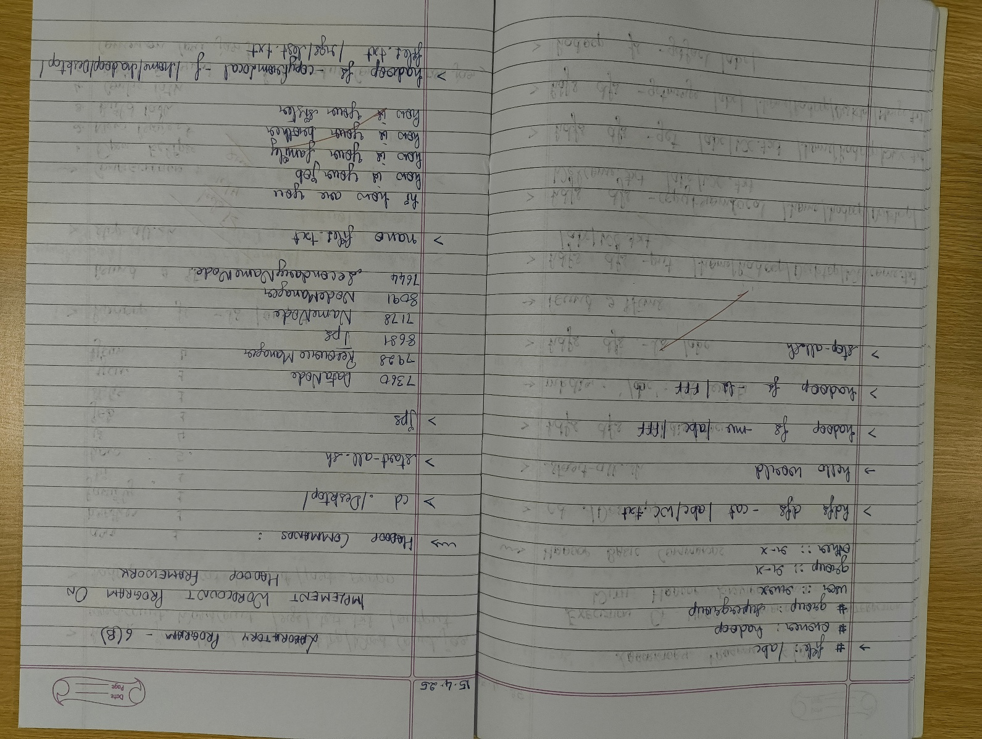

COMMAND WITH OUTPUT









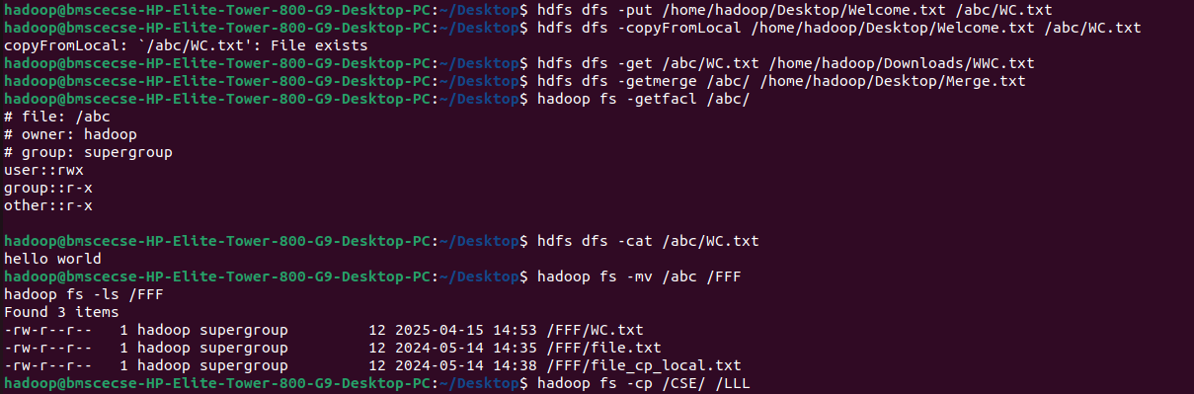







**LABORATORY PROGRAM – 5**

1. **Implement Wordcount program on Hadoop framework**

OBSERVATION

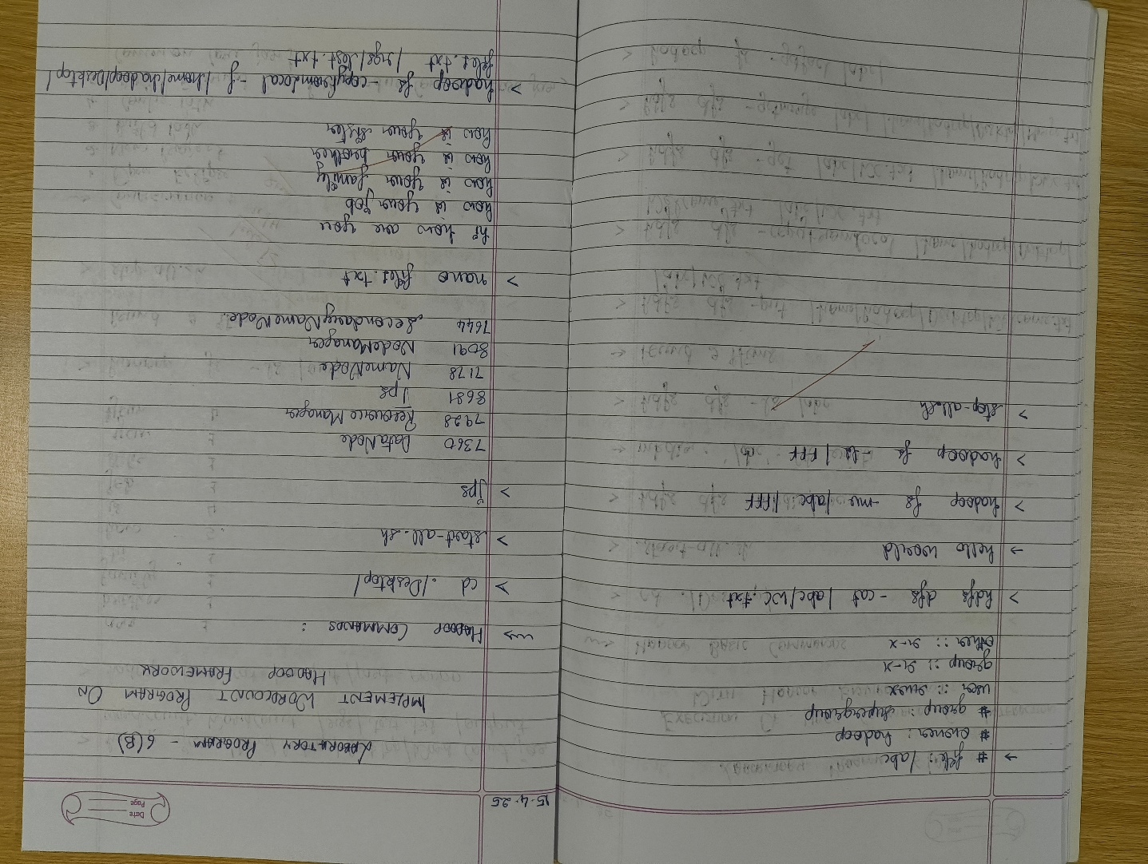 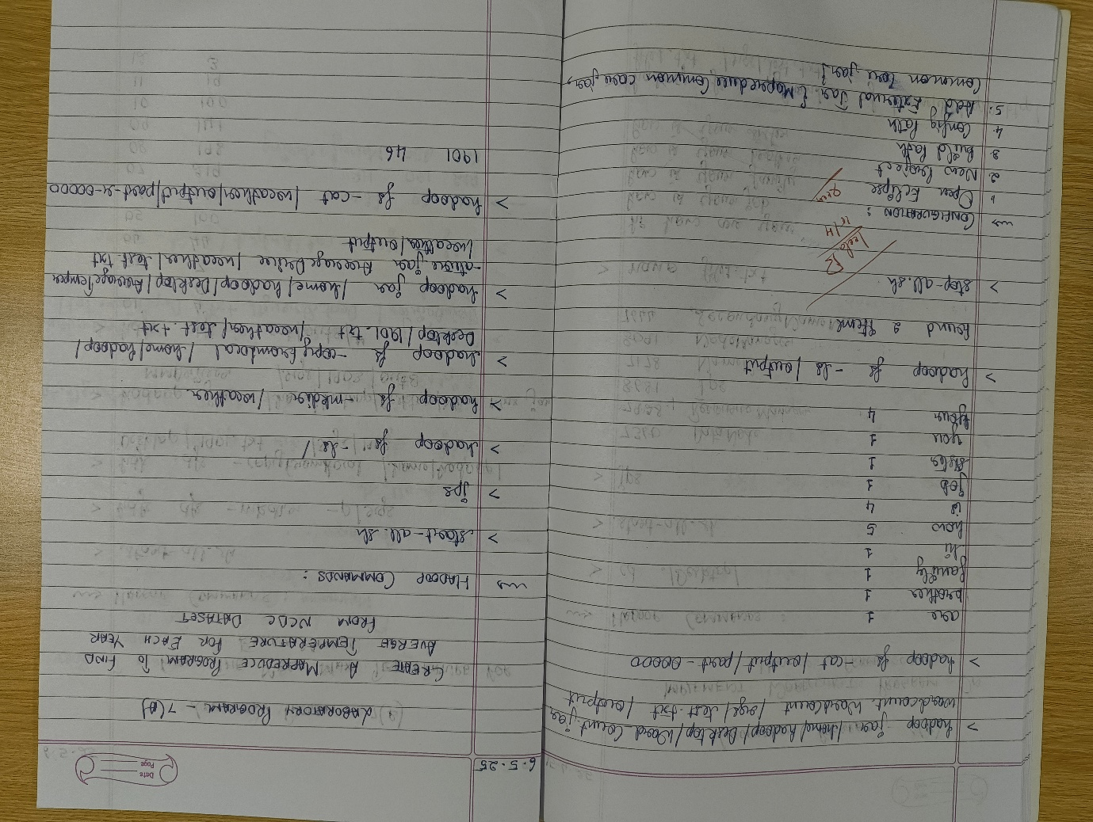

CODE, COMMAND WITH OUTPUT

**Driver Code**

// Importing libraries

import java.io.IOException;

import org.apache.hadoop.conf.Configured;

import org.apache.hadoop.fs.Path;

import org.apache.hadoop.io.IntWritable;

import org.apache.hadoop.io.Text;

import org.apache.hadoop.mapred.FileInputFormat;

import org.apache.hadoop.mapred.FileOutputFormat;

import org.apache.hadoop.mapred.JobClient;

import org.apache.hadoop.mapred.JobConf;

import org.apache.hadoop.util.Tool;

import org.apache.hadoop.util.ToolRunner;

public class WCDriver extends Configured implements Tool {

public int run(String[] args) throws IOException {

if (args.length < 2) {

System.out.println("Please give valid inputs");

return -1;

}

JobConf conf = new JobConf(WCDriver.class);

conf.setJobName("WordCount");

FileInputFormat.setInputPaths(conf, new Path(args[0]));

FileOutputFormat.setOutputPath(conf, new Path(args[1]));

conf.setMapperClass(WCMapper.class);

conf.setReducerClass(WCReducer.class);

conf.setMapOutputKeyClass(Text.class);

conf.setMapOutputValueClass(IntWritable.class);

conf.setOutputKeyClass(Text.class);

conf.setOutputValueClass(IntWritable.class);

JobClient.runJob(conf);

return 0;

}

// Main Method

public static void main(String[] args) throws Exception {

int exitCode = ToolRunner.run(new WCDriver(), args);

System.out.println("Job Exit Code: " + exitCode);

}

}

**Mapper Code**

// Importing libraries

import java.io.IOException;

import org.apache.hadoop.io.IntWritable;

import org.apache.hadoop.io.LongWritable;

import org.apache.hadoop.io.Text;

import org.apache.hadoop.mapred.MapReduceBase;

import org.apache.hadoop.mapred.Mapper;

import org.apache.hadoop.mapred.OutputCollector;

import org.apache.hadoop.mapred.Reporter;

public class WCMapper extends MapReduceBase implements Mapper<LongWritable, Text, Text, IntWritable> {

// Map function

public void map(LongWritable key, Text value, OutputCollector<Text, IntWritable> output, Reporter reporter)

throws IOException {

String line = value.toString();

// Splitting the line on whitespace

for (String word : line.split("\\s+")) {

if (word.length() > 0) {

output.collect(new Text(word), new IntWritable(1));

}

}

}

}

**Reducer Code**

// Importing libraries

import java.io.IOException;

import java.util.Iterator;

import org.apache.hadoop.io.IntWritable;

import org.apache.hadoop.io.Text;

import org.apache.hadoop.mapred.MapReduceBase;

import org.apache.hadoop.mapred.OutputCollector;

import org.apache.hadoop.mapred.Reducer;

import org.apache.hadoop.mapred.Reporter;

public class WCReducer extends MapReduceBase implements Reducer<Text, IntWritable, Text, IntWritable> {

// Reduce function

public void reduce(Text key, Iterator<IntWritable> values,

OutputCollector<Text, IntWritable> output,

Reporter reporter) throws IOException {

int count = 0;

// Counting the frequency of each word

while (values.hasNext()) {

count += values.next().get();

}

output.collect(key, new IntWritable(count));

}

}

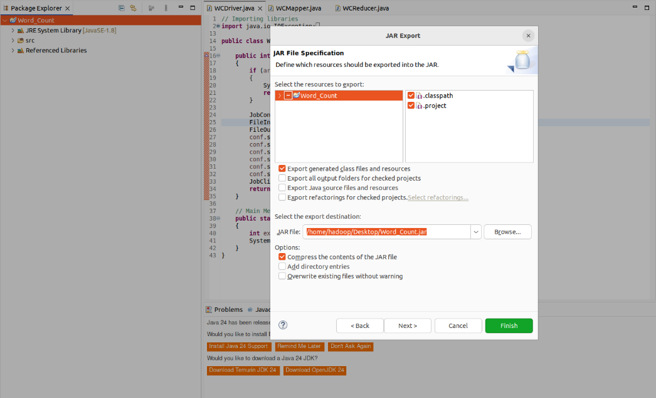

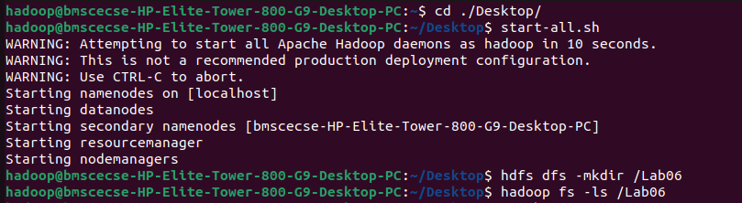

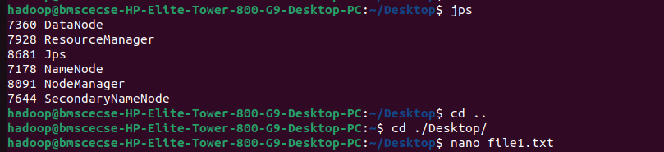

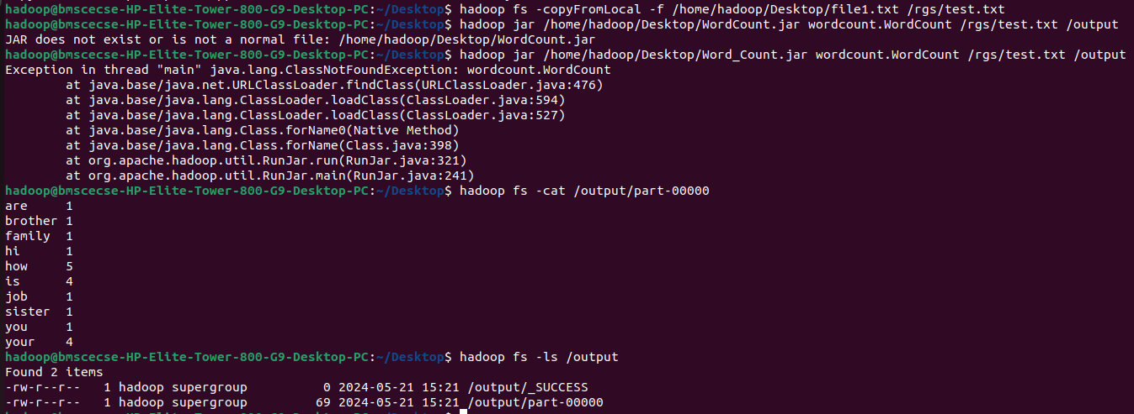

**LABORATORY PROGRAM – 6**

1. **Implement Weather program on Hadoop framework**

**Questions:**

From the following link extract the weather data [https://github.com/tomwhite/hadoopbook/tree/master/input/ncdc/all](https://github.com/tomwhite/hadoopbook/tree/master/input/ncdc/all%20)

a) Create a MapReduce program to find average temperature for each year from NCDC data set.

b) find the mean max temperature for every month.

1. OBSERVATION

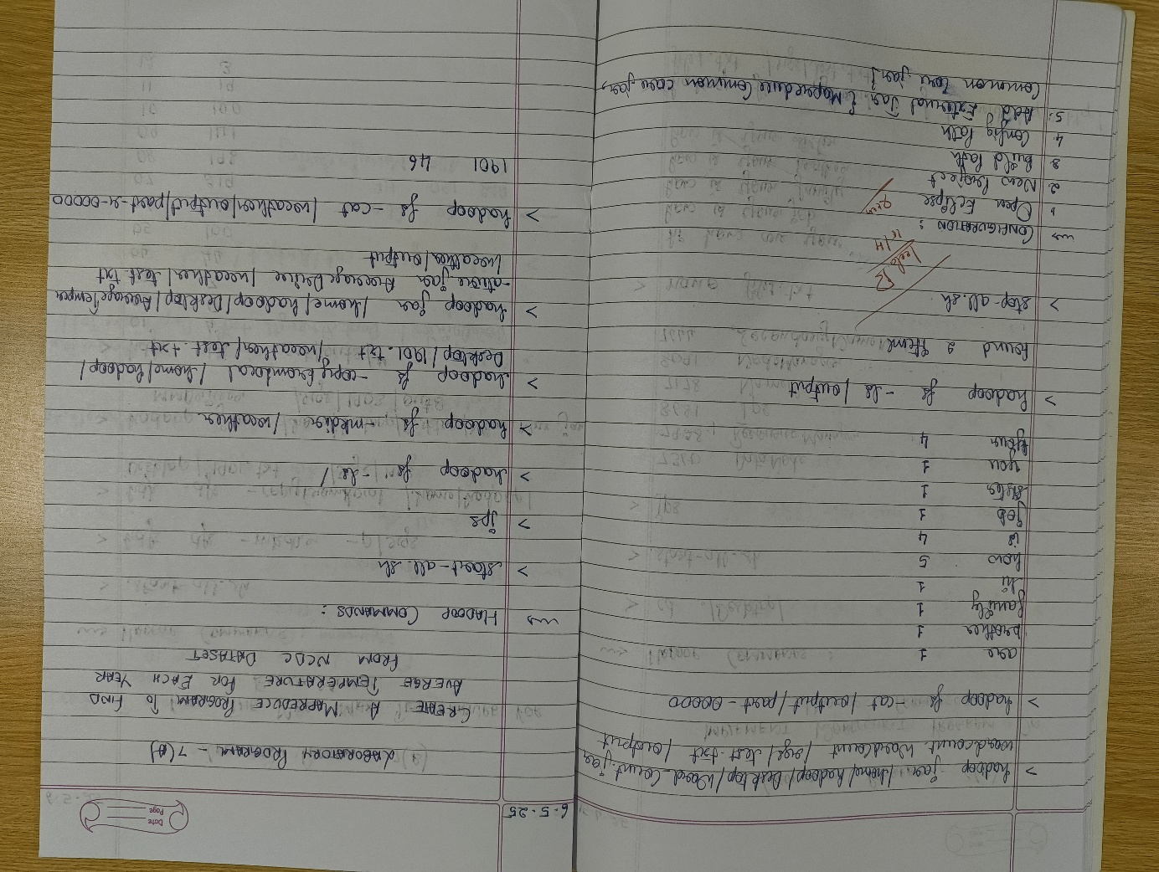 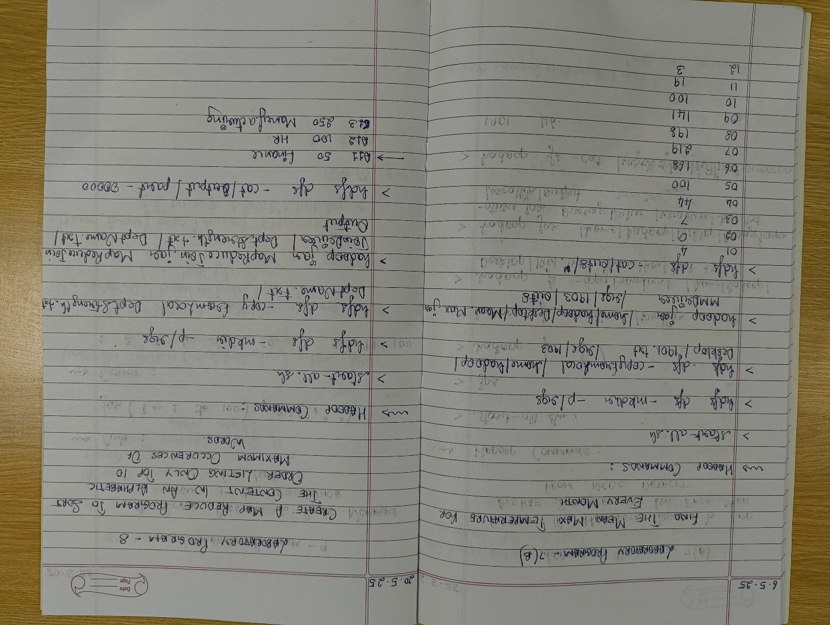

CODE, COMMAND WITH OUTPUT – A

**Driver Code**

package temp;

import org.apache.hadoop.conf.Configuration;

import org.apache.hadoop.fs.Path;

import org.apache.hadoop.io.IntWritable;

import org.apache.hadoop.io.Text;

import org.apache.hadoop.mapreduce.Job;

import org.apache.hadoop.mapreduce.lib.input.FileInputFormat;

import org.apache.hadoop.mapreduce.lib.output.FileOutputFormat;

public class AverageDriver {

public static void main(String[] args) throws Exception {

if (args.length != 2) {

System.err.println("Please enter both input and output parameters.");

System.exit(-1);

}

// Creating a configuration and job instance

Configuration conf = new Configuration();

Job job = Job.getInstance(conf, "Average Calculation");

job.setJarByClass(AverageDriver.class);

// Input and output paths

FileInputFormat.addInputPath(job, new Path(args[0]));

FileOutputFormat.setOutputPath(job, new Path(args[1]));

// Setting mapper and reducer classes

job.setMapperClass(AverageMapper.class);

job.setReducerClass(AverageReducer.class);

// Output key and value types

job.setOutputKeyClass(Text.class);

job.setOutputValueClass(IntWritable.class);

// Submitting the job and waiting for it to complete

System.exit(job.waitForCompletion(true) ? 0 : 1);

}

}

**Mapper Code**

package temp;

import java.io.IOException;

import org.apache.hadoop.io.IntWritable;

import org.apache.hadoop.io.LongWritable;

import org.apache.hadoop.io.Text;

import org.apache.hadoop.mapreduce.Mapper;

public class AverageMapper extends Mapper<LongWritable, Text, Text, IntWritable> {

public static final int MISSING = 9999;

@Override

public void map(LongWritable key, Text value, Context context)

throws IOException, InterruptedException {

String line = value.toString();

// Extract year from fixed position

String year = line.substring(15, 19);

int temperature;

// Determine if there's a '+' sign

if (line.charAt(87) == '+') {

temperature = Integer.parseInt(line.substring(88, 92));

} else {

temperature = Integer.parseInt(line.substring(87, 92));

}

// Quality check character

String quality = line.substring(92, 93);

// Only emit if data is valid

if (temperature != MISSING && quality.matches("[01459]")) {

context.write(new Text(year), new IntWritable(temperature));

}

}

}

**Reducer Code**

package temp;

import java.io.IOException;

import org.apache.hadoop.io.IntWritable;

import org.apache.hadoop.io.Text;

import org.apache.hadoop.mapreduce.Reducer;

public class AverageReducer extends Reducer<Text, IntWritable, Text, IntWritable> {

@Override

public void reduce(Text key, Iterable<IntWritable> values,

Context context) throws IOException, InterruptedException {

int sumTemp = 0;

int count = 0;

for (IntWritable value : values) {

sumTemp += value.get();

count++;

}

if (count > 0) {

int average = sumTemp / count;

context.write(key, new IntWritable(average));

}

}

}

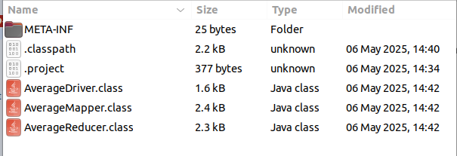

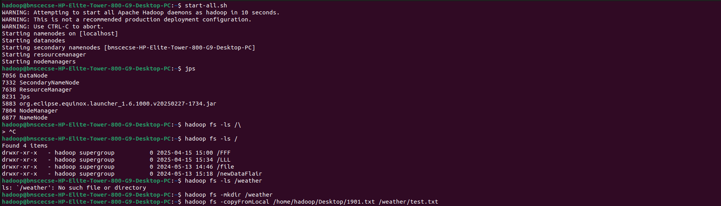

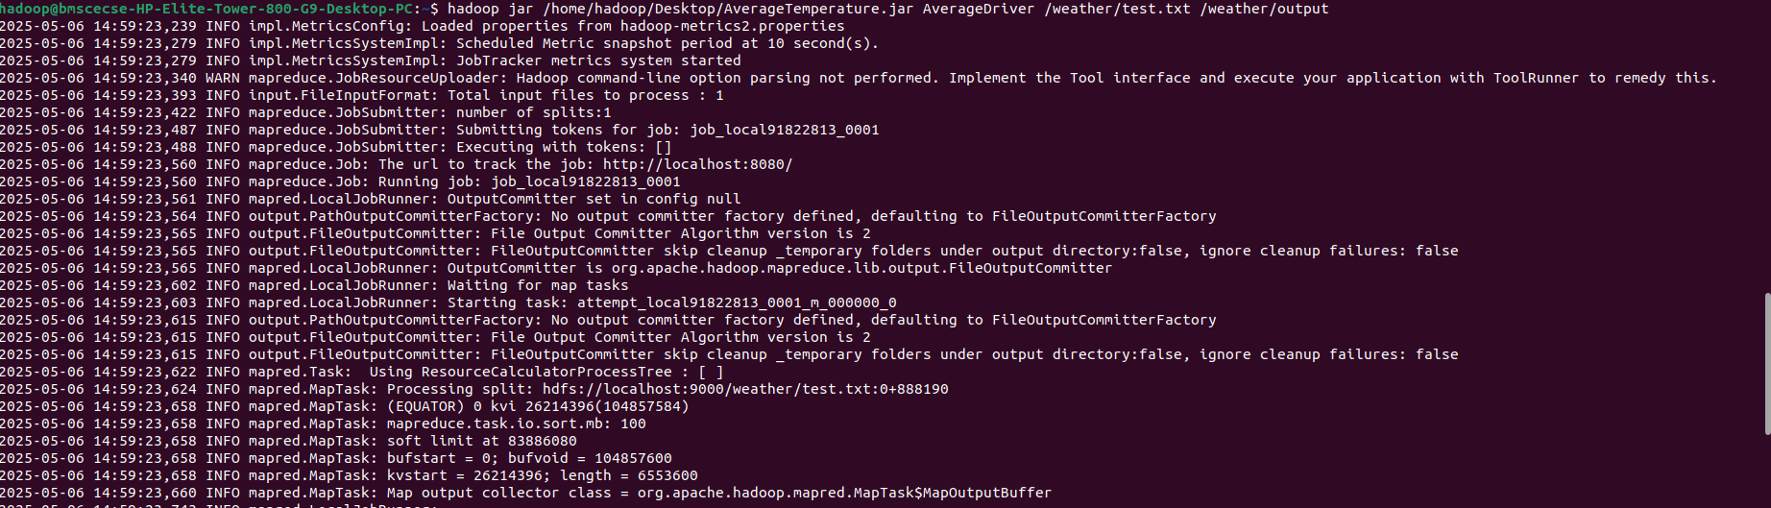

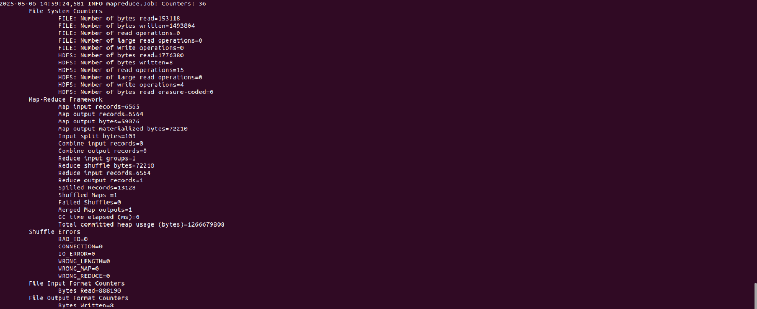

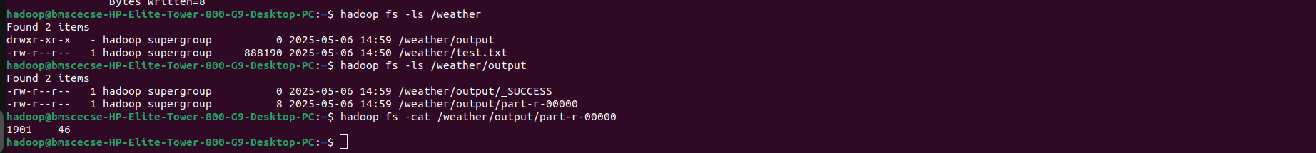

CODE, COMMAND WITH OUTPUT – B

**Driver Code**

package meanmax;

import org.apache.hadoop.conf.Configuration;

import org.apache.hadoop.fs.Path;

import org.apache.hadoop.io.IntWritable;

import org.apache.hadoop.io.Text;

import org.apache.hadoop.mapreduce.Job;

import org.apache.hadoop.mapreduce.lib.input.FileInputFormat;

import org.apache.hadoop.mapreduce.lib.output.FileOutputFormat;

public class MeanMaxDriver {

public static void main(String[] args) throws Exception {

if (args.length != 2) {

System.err.println("Please enter both input and output parameters.");

System.exit(-1);

}

Configuration conf = new Configuration();

Job job = Job.getInstance(conf, "Mean and Max Temperature");

job.setJarByClass(MeanMaxDriver.class);

FileInputFormat.addInputPath(job, new Path(args[0]));

FileOutputFormat.setOutputPath(job, new Path(args[1]));

job.setMapperClass(MeanMaxMapper.class);

job.setReducerClass(MeanMaxReducer.class);

job.setOutputKeyClass(Text.class);

job.setOutputValueClass(IntWritable.class);

System.exit(job.waitForCompletion(true) ? 0 : 1);

}

}

**Mapper Code**

package meanmax;

import java.io.IOException;

import org.apache.hadoop.io.IntWritable;

import org.apache.hadoop.io.LongWritable;

import org.apache.hadoop.io.Text;

import org.apache.hadoop.mapreduce.Mapper;

public class MeanMaxMapper extends Mapper<LongWritable, Text, Text, IntWritable> {

public static final int MISSING = 9999;

@Override

public void map(LongWritable key, Text value, Context context)

throws IOException, InterruptedException {

String line = value.toString();

// Extract month from positions 19-20

String month = line.substring(19, 21);

int temperature;

// Extract temperature considering optional '+'

if (line.charAt(87) == '+') {

temperature = Integer.parseInt(line.substring(88, 92));

} else {

temperature = Integer.parseInt(line.substring(87, 92));

}

// Quality check

String quality = line.substring(92, 93);

if (temperature != MISSING && quality.matches("[01459]")) {

context.write(new Text(month), new IntWritable(temperature));

}

}

}

**Reducer Code**

package meanmax;

import java.io.IOException;

import org.apache.hadoop.io.IntWritable;

import org.apache.hadoop.io.Text;

import org.apache.hadoop.mapreduce.Reducer;

public class MeanMaxReducer extends Reducer<Text, IntWritable, Text, Text> {

@Override

public void reduce(Text key, Iterable<IntWritable> values,

Context context) throws IOException, InterruptedException {

int sumTemp = 0;

int count = 0;

int maxTemp = Integer.MIN_VALUE;

for (IntWritable value : values) {

int temp = value.get();

sumTemp += temp;

count++;

if (temp > maxTemp) {

maxTemp = temp;

}

}

if (count > 0) {

int avgTemp = sumTemp / count;

String result = "mean=" + avgTemp + " max=" + maxTemp;

context.write(key, new Text(result));

}

}

}

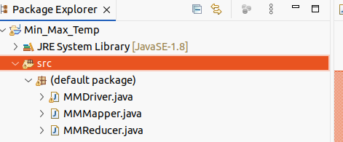

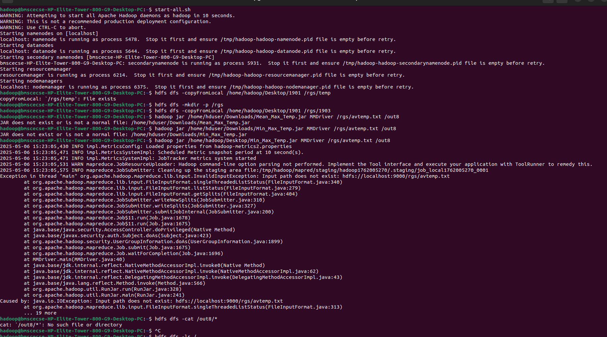

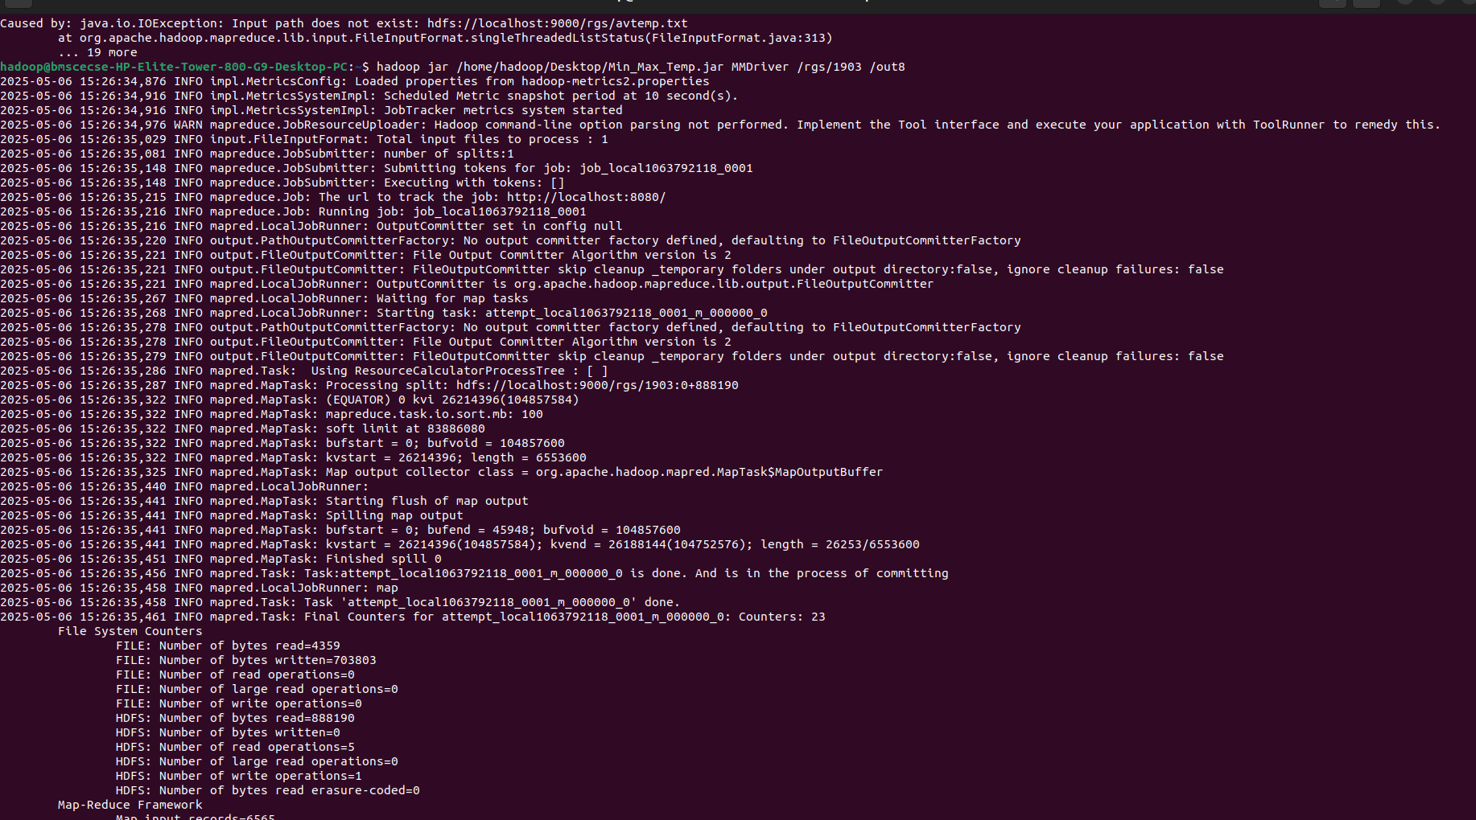

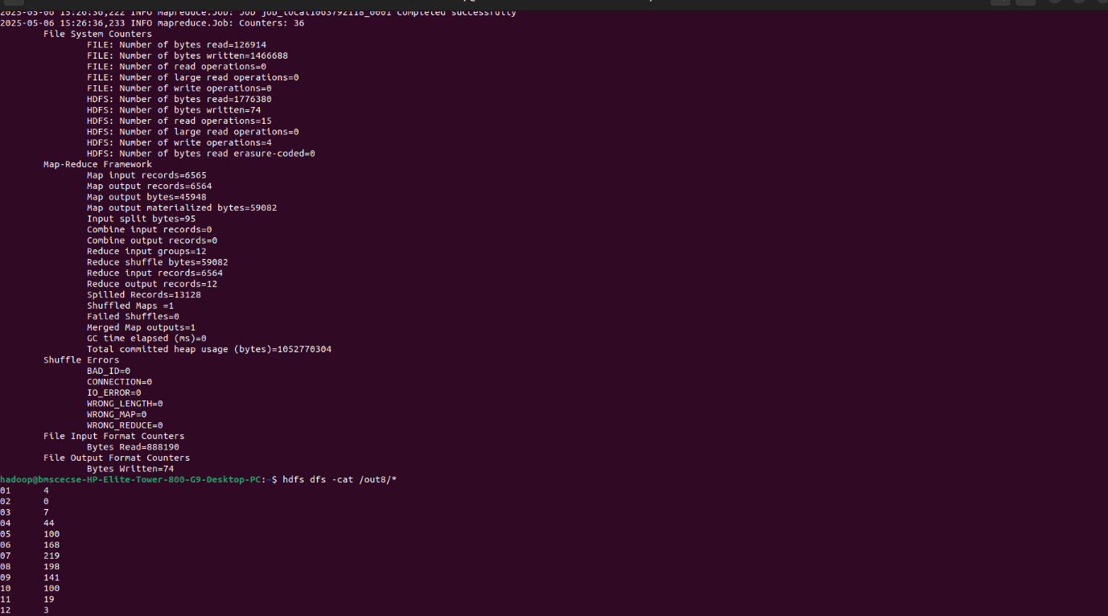



**LABORATORY PROGRAM – 7**

**For a given Text file, Create a Map Reduce program to sort the content in an alphabetic order listing only top 10 maximum occurrences of words.**

1. OBSERVATION

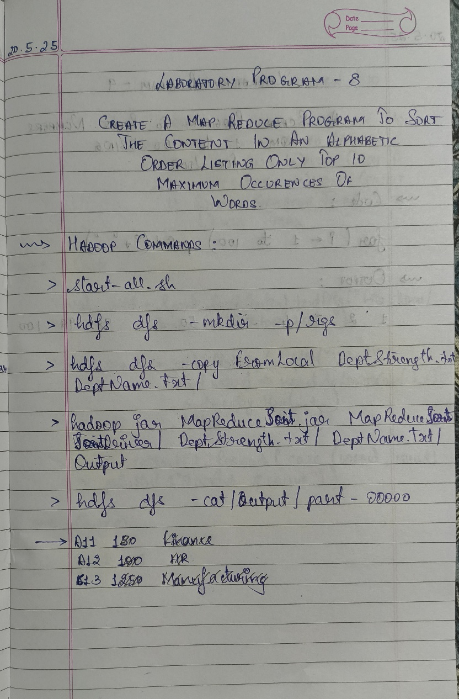

CODE, COMMAND WITH OUTPUT

**Driver Code (TopNDriver.java)**

package samples.topn;

import org.apache.hadoop.conf.Configuration;

import org.apache.hadoop.fs.Path;

import org.apache.hadoop.io.IntWritable;

import org.apache.hadoop.io.Text;

import org.apache.hadoop.mapreduce.Job;

import org.apache.hadoop.mapreduce.lib.input.FileInputFormat;

import org.apache.hadoop.mapreduce.lib.output.FileOutputFormat;

public class TopNDriver {

public static void main(String[] args) throws Exception {

if (args.length != 3) {

System.err.println("Usage: TopNDriver <in> <temp-out> <final-out>");

System.exit(2);

}

Configuration conf = new Configuration();

// === Job 1: Word Count ===

Job wcJob = Job.getInstance(conf, "word count");

wcJob.setJarByClass(TopNDriver.class);

wcJob.setMapperClass(WordCountMapper.class);

wcJob.setCombinerClass(WordCountReducer.class);

wcJob.setReducerClass(WordCountReducer.class);

wcJob.setOutputKeyClass(Text.class);

wcJob.setOutputValueClass(IntWritable.class);

FileInputFormat.addInputPath(wcJob, new Path(args[0]));

Path tempDir = new Path(args[1]);

FileOutputFormat.setOutputPath(wcJob, tempDir);

if (!wcJob.waitForCompletion(true)) {

System.exit(1);

}

// === Job 2: Top N ===

Job topJob = Job.getInstance(conf, "top 10 words");

topJob.setJarByClass(TopNDriver.class);

topJob.setMapperClass(TopNMapper.class);

topJob.setReducerClass(TopNReducer.class);

topJob.setMapOutputKeyClass(IntWritable.class);

topJob.setMapOutputValueClass(Text.class);

topJob.setOutputKeyClass(Text.class);

topJob.setOutputValueClass(IntWritable.class);

FileInputFormat.addInputPath(topJob, tempDir);

FileOutputFormat.setOutputPath(topJob, new Path(args[2]));

System.exit(topJob.waitForCompletion(true) ? 0 : 1);

}

}

**Mapper Code (WordCountMapper.java)**

package samples.topn;

import java.io.IOException;

import java.util.StringTokenizer;

import org.apache.hadoop.io.IntWritable;

import org.apache.hadoop.io.Text;

import org.apache.hadoop.mapreduce.Mapper;

public class WordCountMapper

extends Mapper<Object, Text, Text, IntWritable> {

private final static IntWritable ONE = new IntWritable(1);

private Text word = new Text();

// characters to normalize into spaces

private String tokens = "[_|$#<>\\^=\\[\\]\\*/\\\\,;,.\\-:()?!\"']";

@Override

protected void map(Object key, Text value, Context context)

throws IOException, InterruptedException {

// clean & tokenize

String clean = value.toString()

.toLowerCase()

.replaceAll(tokens, " ");

StringTokenizer itr = new StringTokenizer(clean);

while (itr.hasMoreTokens()) {

word.set(itr.nextToken().trim());

context.write(word, ONE);

}

}

}

**Mapper Code (TopNMapper.java)**

package samples.topn;

import java.io.IOException;

import org.apache.hadoop.io.IntWritable;

import org.apache.hadoop.io.Text;

import org.apache.hadoop.mapreduce.Mapper;

public class TopNMapper

extends Mapper<Object, Text, IntWritable, Text> {

private IntWritable count = new IntWritable();

private Text word = new Text();

@Override

protected void map(Object key, Text value, Context context)

throws IOException, InterruptedException {

// input line: word \t count

String[] parts = value.toString().split("\\t");

if (parts.length == 2) {

word.set(parts[0]);

count.set(Integer.parseInt(parts[1]));

// emit count → word, so Hadoop sorts by count

context.write(count, word);

}

}

}

**Reducer Code (WordCountReducer.java)**

package samples.topn;

import java.io.IOException;

import org.apache.hadoop.io.IntWritable;

import org.apache.hadoop.io.Text;

import org.apache.hadoop.mapreduce.Reducer;

public class WordCountReducer

extends Reducer<Text, IntWritable, Text, IntWritable> {

@Override

protected void reduce(Text key, Iterable<IntWritable> values, Context context)

throws IOException, InterruptedException {

int sum = 0;

for (IntWritable val : values) {

sum += val.get();

}

context.write(key, new IntWritable(sum));

}

}

**Reducer Code (TopNReducer.java)**

package samples.topn;

import java.io.IOException;

import java.util.ArrayList;

import java.util.Collections;

import java.util.List;

import java.util.Map;

import java.util.TreeMap;

import org.apache.hadoop.io.IntWritable;

import org.apache.hadoop.io.Text;

import org.apache.hadoop.mapreduce.Reducer;

public class TopNReducer

extends Reducer<IntWritable, Text, Text, IntWritable> {

// TreeMap with descending order of keys (counts)

private TreeMap<Integer, List<String>> countMap =

new TreeMap<>(Collections.reverseOrder());

@Override

protected void reduce(IntWritable key, Iterable<Text> values, Context context)

throws IOException, InterruptedException {

int cnt = key.get();

List<String> words = countMap.getOrDefault(cnt, new ArrayList<>());

for (Text w : values) {

words.add(w.toString());

}

countMap.put(cnt, words);

}

@Override

protected void cleanup(Context context)

throws IOException, InterruptedException {

// collect top 10 word→count pairs

List<WordCount> topList = new ArrayList<>();

int seen = 0;

for (Map.Entry<Integer, List<String>> entry : countMap.entrySet()) {

int cnt = entry.getKey();

for (String w : entry.getValue()) {

topList.add(new WordCount(w, cnt));

seen++;

if (seen == 10) break;

}

if (seen == 10) break;

}

// sort these 10 entries alphabetically by word

Collections.sort(topList, (a, b) -> a.word.compareTo(b.word));

// emit final top 10 in alphabetical order

for (WordCount wc : topList) {

context.write(new Text(wc.word), new IntWritable(wc.count));

}

}

// helper class

private static class WordCount {

String word;

int count;

WordCount(String w, int c) { word = w; count = c; }

}

}

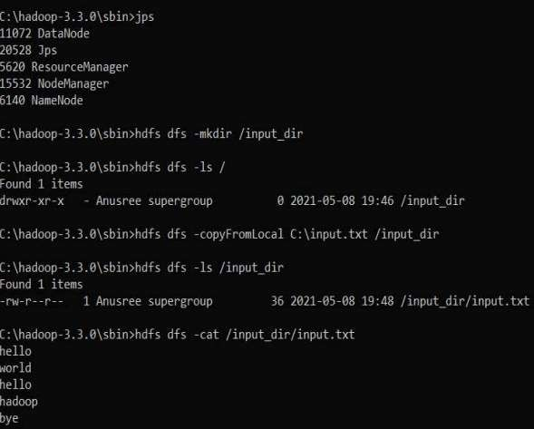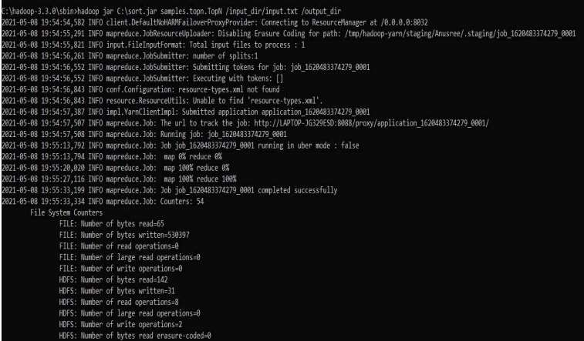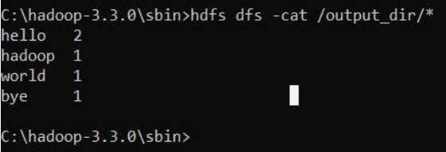

**LABORATORY PROGRAM – 8**

**Write a Scala program to print numbers from 1 to 100 using for loop.**

1. OBSERVATION

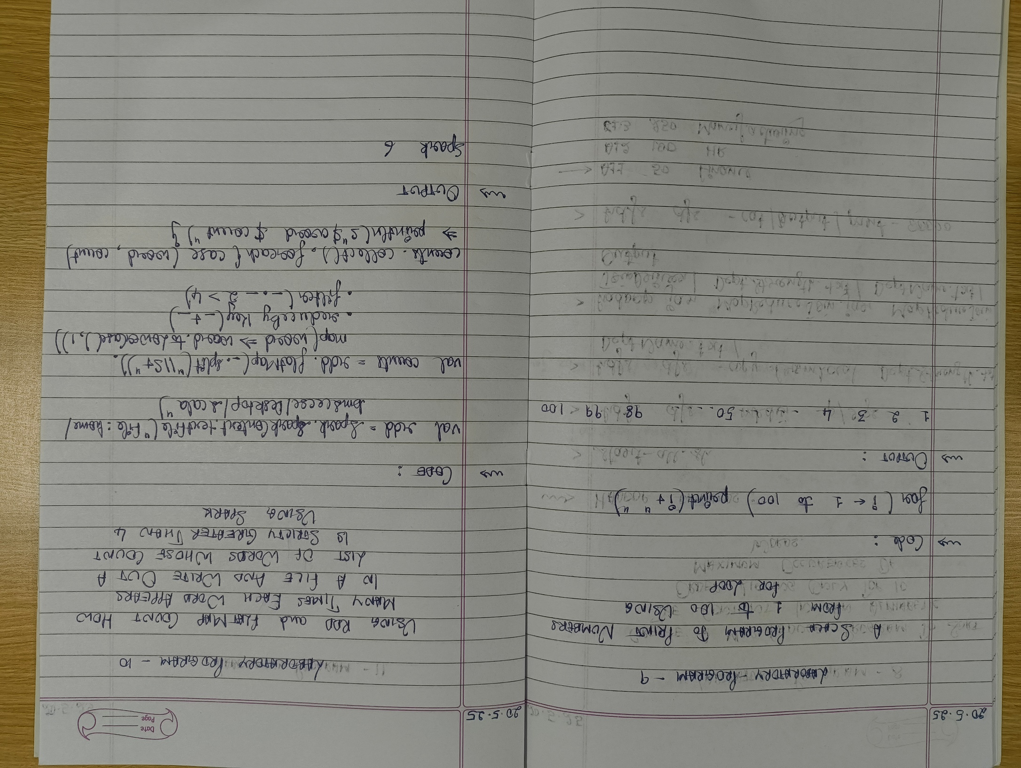

CODE, COMMAND WITH OUTPUT

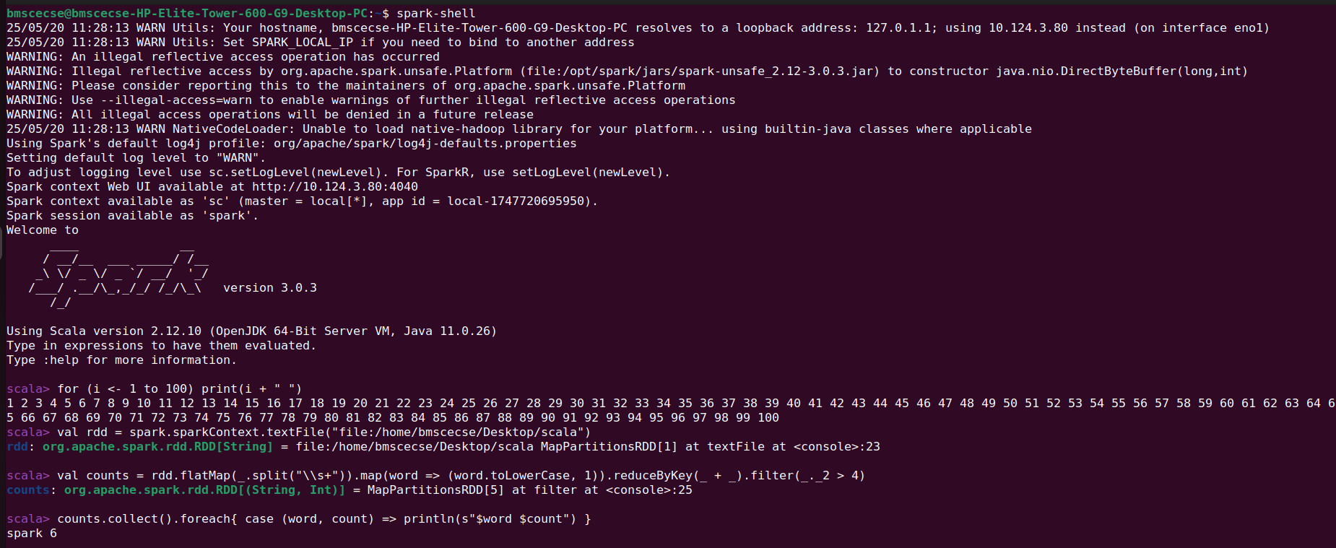

**LABORATORY PROGRAM – 9**

1. **Using RDD and FlatMap count how many times each word appears in a file and write out a list of words whose count is strictly greater than 4 using Spark.**
2. OBSERVATION

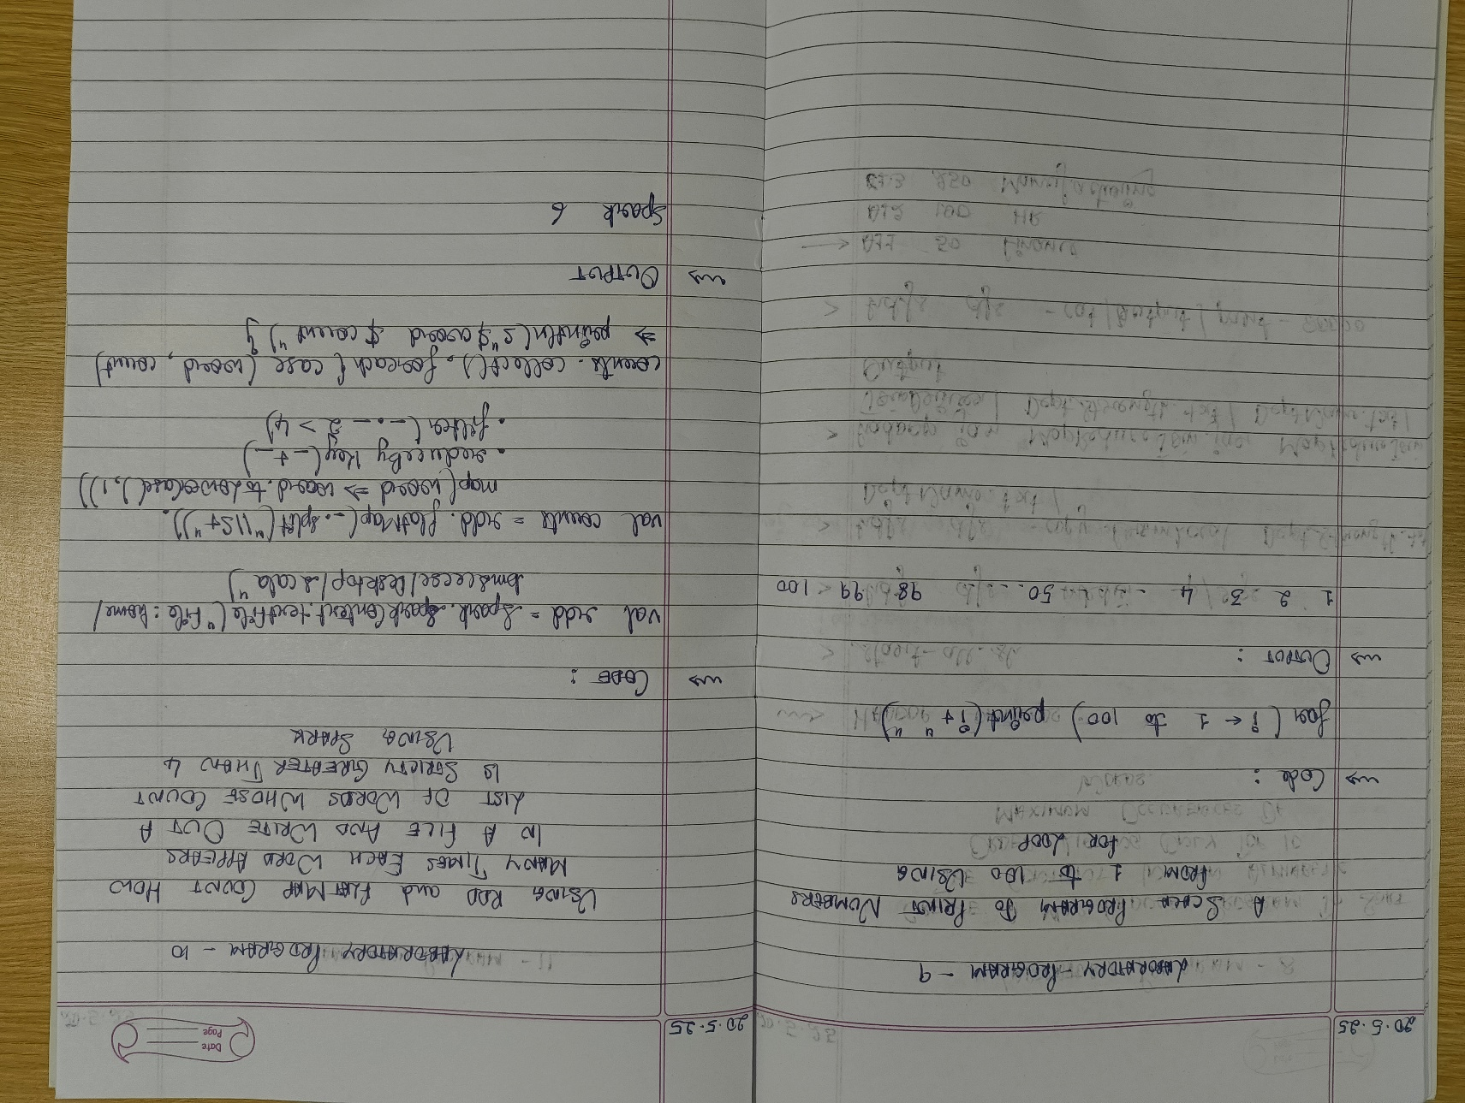

CODE, COMMAND WITH OUTPUT

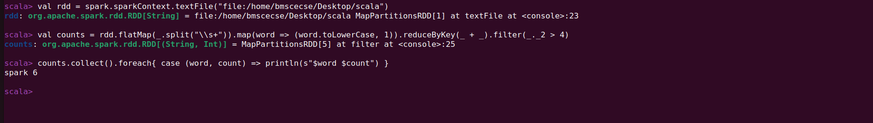

**LABORATORY PROGRAM – 10**

1. **Write a simple streaming program in Spark to receive text data streams on a particular port, perform basic text cleaning (like white space removal, stop words removal, lemmatization, etc.), and print the cleaned text on the screen. (Open Ended Question).**
2. OBSERVATION

CODE, COMMAND WITH OUTPUT

# Install NLTK and download required data (run once)

!pip install nltk

import nltk

nltk.download('punkt')

nltk.download('stopwords')

nltk.download('wordnet')

from pyspark.sql import SparkSession

from pyspark.sql.functions import col, lower, regexp_replace, split, explode, udf

from pyspark.sql.types import ArrayType, StringType

from pyspark.ml.feature import StopWordsRemover

from nltk.stem import WordNetLemmatizer

# Initialize SparkSession

spark = SparkSession.builder.appName("TextProcessing").getOrCreate()

# Define your input lines

lines = [

    "Hello, I hate you.",

    "I hate that I love you.",

    "Don't want to, but I can't put",

    "nobody else above you."

]

# Create DataFrame from lines

df = spark.createDataFrame(lines, "string").toDF("value")

# Step 1: Lowercase and remove punctuation

df_clean = df.select(regexp_replace(lower(col("value")), "[^a-zA-Z\\s]", "").alias("cleaned"))

# Step 2: Tokenize the cleaned text

df_tokens = df_clean.select(split(col("cleaned"), "\\s+").alias("tokens"))

# Step 3: Remove stop words

remover = StopWordsRemover(inputCol="tokens", outputCol="filtered")

df_filtered = remover.transform(df_tokens)

# Step 4: Lemmatization using NLTK WordNetLemmatizer with UDF

lemmatizer = WordNetLemmatizer()

def lemmatize_words(words):

    return [lemmatizer.lemmatize(word) for word in words]

lemmatize_udf = udf(lemmatize_words, ArrayType(StringType()))

df_lemmatized = df_filtered.withColumn("lemmatized", lemmatize_udf(col("filtered")))

# Step 5: Explode the lemmatized words and show results

df_lemmatized.select(explode(col("lemmatized")).alias("word")).show(truncate=False)

